•2 Femela/Wtil& (t(ET-25_0_02F WJ

'·. 2.NJIONC
P FET( fleldEhectTransistor
M"""NC
L E!lowetSwltcl\. BIOWElfAee1Mor

'·L

aG•
<.VO

.A
&.

7.-
8.13<
9.G

10.-
•36 F-emar G'eenf:JST_WtC_36F_Q)

VP.b'lction8ax•AISA 10A 19.8 <ft.nl(GM04)
:io
ll1A'l.rnllnlCU.(A.it�IND 21.G ecM(Cr•$1'1Urt:>c
on.... AilS..g. """'(15'S&ltgf 22.G/8 0.W.1A.i �'Migh (2ncl 8'agtt
on.... AilS..g- Low(tst 8'agt) 23. °'"'"'' � Low(2nd$tag4t)
.

24.-
2$.-
on....F1SMigh ..... P•�1FIS�
CCANM9'1 27.-
28.
-
...
T911talel..aq> 30.
PMisonsi-AilS.11•�(1M St.19D) 3t .G
PMisonsi-AilS.si•l.ow( IM S..�

az. P•�1Ai1�·

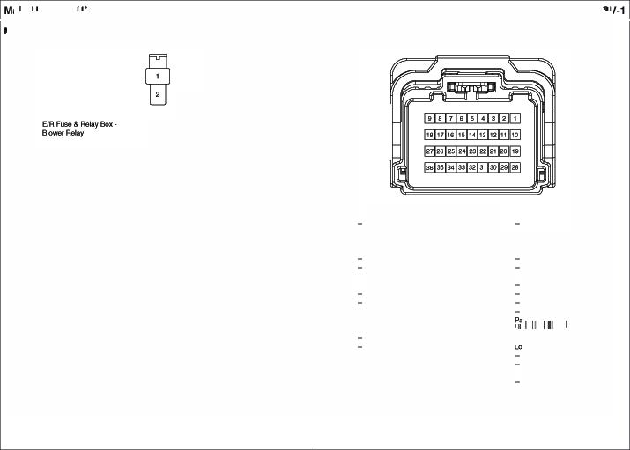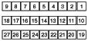

18.0
on....F1SLow 33.
  - ANLow34.
3$. P•�• FIS l.ow

36.

Ev..,orator Sensor
    - 2FEl'l'ltlll&/Wti'I& _W) • 1e F-emalat�te(AJ.1P_000111_ eF _W)

- AUIGAIC 2."' NC"°"""'IAo<U& '· - - •. - -
w NCContrOI Module(Seneol .. . - •O.- -
M....... NC a- - 11.- -

"' NCContrOI Module(Seneol 4.13< Ra$hoJSoutv:IRell!)'
,,__ -

lol04-A IC loy Box
(llP.AltdanSox• HAZAFI> 1$A) 13. -
$.Y Ra$hoJ Soutv:I Flelll!Y(9CM) 14. - -
.. . - •$.- -

•20 Female Iv,tilte (MIP _090lll_2<lf _W) 7. - - 16.- -
- -

� lncerSensor (Auto A1C'J
  - 6FemaleIwtjje(KET_91AJ)6F_W)

  - Br ------ 11.l Fleet Wipe Aela
2.W/9 --- (llPJunction Box· w.P AA 15�
(� CM1re1Moch.e) 12.w Fleet Wipe Aela
ao D8CAel&y(ESC UocU&. (Aeef�Mo'Or
""'_,,..., """'- 1a- -
S�l.aftl)LWFIKJ 14.- - '· - - ••• NCC.O..ol Mo<llle(Sen6of+)
•.- - 15.8 TWGTum U'*dc Aelay 2.0< A/CCon1tcl Mod!Ae(Sen9orGrOU"ld) s. - -
5.W/9 08CAel&y (ESC UocUeJ (Grourd (GM02)) a- - .. - -
"'"' 08CAel& 16.Y/8 TWGTum U'*dc Aelay (WP.Andkl'I Box MOO Ll.E I 10A) (IPS Cof'l\'OI Med.lie)

7.0
&l | D8C ..�,(8'op.._""""" 17.8t  08CAel& |  | (llPJunction Box· DALOC
 | (El - &. | 18.0 | TWGTum U'*dc Aelay
··- | STOPLPIOA  - | 19.- | (Dool LockActualOI)  -
10.- | - | 20.- | -

TWGTum U'*dc Aelay

15A
- 7 FemaleIwtlile(KUM DFL07 _W)

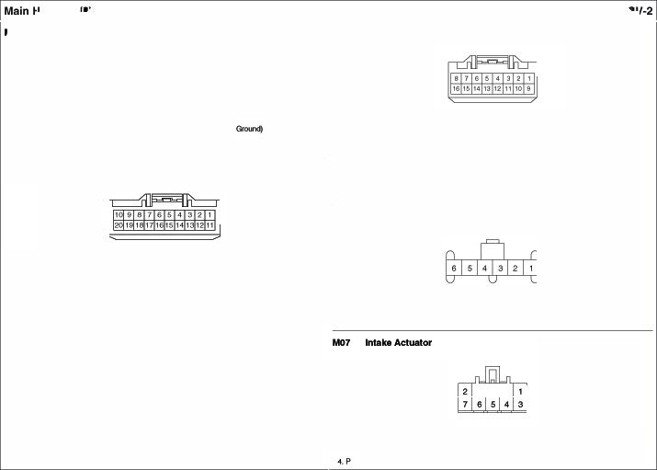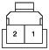

'· - - .. .. NCCo<wol -�(V'91)
2. - .."' NCC.O..olMo<kile(FIS)
3..At/toNC• BrIManual NC•8 7."' NC C.O..olMo<klle(Sen6ofONO) A/CCon1tcl Mod!Ae(FAE)
A/CCon1tcl Mod!Ae(REC)

lot09 lgn•lon Key LL.& Door Warning Swlleh CHIO8111111 Key
• 6Ma/a/�lel,l(ET 09011_06M_W)

•24 F-emara/�te l)(ET_040IU4 _W)

1.w 2.81
3.8

AnlEI A'*'ma(+)
�(GMo1)

••• 5.G
6.G

9CM• &.itch 111)1.11
9CM · �Hole ILL
�p�!Ion Box ROOMLP 10A

1.•
2.8'

llPJonctlonBox• FK>OMLP 1OA 13.lJO
llPJonctlonBox•M<XM.llE S7.SA 14.l

., .MdonBox·ALO:)210A Rei vmhEwSl'itn

3.G
<.W
llPJonctlonBox•M<XM.U 21OA 1S.Gl8 TumSigna SwitchlH 16.0
Reil Wipe!"&.itch Rei Wipe!"• I NT,

M1 Ollla UnkConnector
•16 Female I Bla(:l((Ml.X_OBOH_IO:_B_SIN)
.. .
6.8'18
7 .G
.. .
.. .
10, -
11. y
12.G
TumSigna Switch RM 17 .Br
-·UpSigna 18.Wi9
SA (Cfnh tkllock) 19 .p
....Llgl'IS.0.0. 20.YIB
- 21. p
- 2.2.y
Hozwd6"'1ch 23.G/8
.,...,..,, 24.8
FrcntWa&her&.itch Fr cnt ·INT. Frcnt�·Mlst Frcnt�- INT.(Time
Ooof Wimlng Switch• inp.,,. TalLamp Sl'itn
Keoj �19f Lodi:Sl'itn
<nund(GMo1

1.-
··-
3.G
4.
•.

a-
- O.G �pJunction Box•ROOM LP IOA
- 10.- -
CC.AN High 11.0 CCANl.ow
�(GM01) -
�(GM01) 13. w
Vet'lic*tSpeedSi9"-' -
- 15. - -
- 1e.- -

M13-ll DCM
•20 Rwnal /'r\tllte l){ET_<MOll_20F_W)

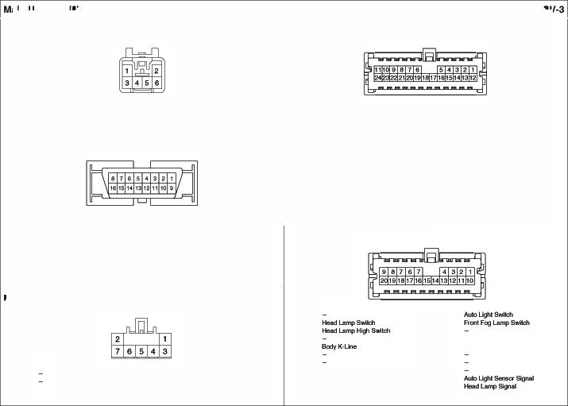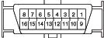

1.-
2.-
3.l
...
UOdeAclUalOf
• 1FGn111111rt/WJ'ia(KUM..,COF\.,01 ..W)

NCContrOIModule(OEf) NCContrOIModule(VENT)

5."'
6.G
7.1>

NCColWol McdA&( SEwlofGNO) NCCo<Wol"""°(FIB)
NCColWol McdA&(Vt

1.-
2.l
3. p 4.- 5.W
6.-
7.-
aL
•••
10.W

&CA Hig 11-CANL.ow
Al.Aoligh GrCU'ld

11.y 12.0 13.-
14.W
15.W
16.-
17.- 1a-
19. R 20.

FICll'll�Dei::iel'Wk:hk'lpll Rea �tch ,..

·24 Female I Grftf(KE"r_04011F1_24 _GFLB) •24 l=emala/�tel)(ET_025_PCB_2<1 F_W)

1

1.0 | Se.tetyPowetWindow | 13.- | -
2.""' | SecuVfINO. | 14.- | -
3.0 | Door U'*>r:*S""8J | 15.- | -
•.<>8  5.Br | Room.......""'""' | 16.-  17.G | -  Key HOie ILL Col'U
6.G< | Tur�dlampOUlpUI· FL | 16.- | -
7.YIB | Tur�dlampOUlpUI· FR | 19.0 | ANTaiSip!
aw  ••• | Tur�dlampOUlpUI· Fl. Tur�dlampOUlpUI· RR | "'·y  21.0IB | �Sou'ldRNy  FfOl'l W�Rela

10.8'WJl#IO'lion Box
•
HAZA.A 16A 22 - -

-
1 .G  ZG1IO 3.""'  ··-  $.G  &. | VP.b'lction8ax• ROOMl.P 1QA VP.b'lction8ax•Q.USTE'RIOA  ILL.(•)  -  CCAN C.CANLow | 13.L  14.  1$.G  16.0  17 .Bt  18.- | MocktSwiktl  Atwosu.I �&.itch Atwosu.I[)ownSMktl Fuel S.ncler (•)  .. NsoOutput (AIT}  -
7.- | - | 19. - | -
..  ••• | e.cANMig e-cANLow  - | :io.  21.uo  22 | -  ll..(-)  Fuel S.ncler (•)
 | VGhdrtSptodkl!M(MIT) | 23 | Qo.n:I (GMO
 | - | 24 | Qo.n:I (GMO

- 81 WJl#IO'lion Box
•
HAZA.A
16A
23.-
- -

- B GrOU'ld (GUOI 24.
M15-8 ln8tNmenl: au.ter
FET (Field Eltoct Tranoloto<)(Auto A/C) • 16 Fem v.tiite (AMP 16F..W)
  - 4fernElkl/Black(KET_2SO_OtF_8)

'
I,- - 9.G 0.wg9NJ
I.p 8i0¥fel' MW. 3.8 Glound (GJ402) 2.- - IO.G1 SAS IND

2.R "''"' '"'18 Gole 3.VO VP.b'lction8ax
•
AIS N>IOA 11.- -

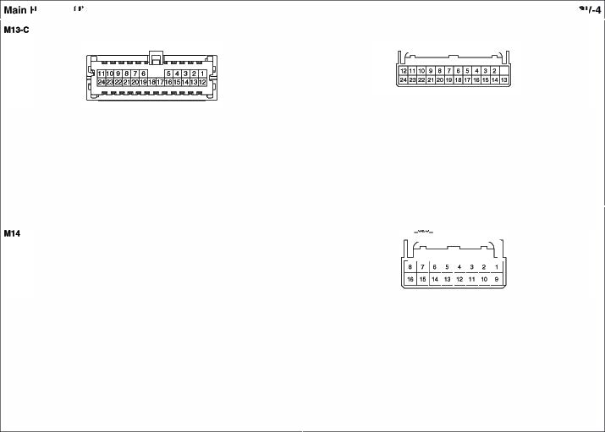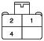··- - 12.- -
$.- - 13.- -
&.8</0 WIO SmwtKtJt• IMMO. INO. 14. YAJ Ch-=* Eng i11tINO.
Wilh SmwtKt¥• 1$.- -
SmartKevCcrllrd Moch• 16 - -
7.- -
8.YA! OI PtHsi.n Switch

A utoUghl "Photo--
•8FEl'l'ltlll&/Wti'I& (KET_91A..OO/I_WJ 06f ...,S./� (KllM..DSO..OGF..WJ

1.R AIM>LighliSen&Of•Signal 5.RI() 8CM· Se<urifyNO.
2.W 1. R EiflFUN&AelQlfBox· tGN 2<tQA 4. �Of S TAR OJrpot
AIM>LighliSen&Of•Ground 6.L A'"° NC Sm (·) (cm.

3. A "10NC Sm(.)(- 7. 8' A'*> NCCof*OtModAe ·Vrei1
4.UB l'P.Ainc*on8ox ROOMlP IOA 6.R A'*> Ligtt6en&Of •&lpply
�L ONau,,.,, 5.P EIR fu;e& RetrayBox·IGH 1 »".
3.0 o.

M17·A EPS Con1rol U- M1 Key SolenoldfN/OSmart Key& Alf
• 2 female/Slack(A.M _376_02F..B) •2 f...,,.,�<KET ..�..WJ.)
m

1.8 -(GMO<) ••• EI �&Aday Bax• MOPS 80A

M17·8 EP Con1rol Modulo
•8FEl'l'ltlll&/Black(PKOJ.1..2)
- WIS l/PJonolionBox•SMART KEY 10A 2."" !ICM

M2o.1. MultltunctlonSwHch(Light)
  - 13 Rwnal /'Mllte l){ET_ 3F_W)

1.R | l/P.)Jnc9on8ox·MOOUL£ 1 IOA | 5.- | -
2.- | - | 6.- | -

3.- - 7.0 C-CIH'¥
•.- - 6.0 C-CIHl.OW

1.y

ec Tai Lamp SwllCh

..- -

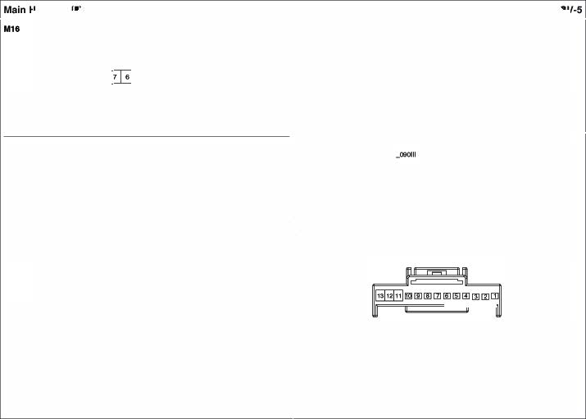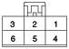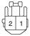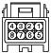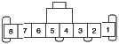�8 G10U'ld(OM ) 6.P !ICM· ..... ......,,......
3.y ecw.AUii>Ugl'ilSwitch 10. 8CM •HeedLampLow Signal
4.L ecw. H9Eld L8111>s.ilth 11.w 8CM• T..rn �LampS�LH
5.8 G10U'ld(OM ) 12.8rl0 � p..b'ldk>nBox· MOOll.E 1 10A
6. ecw. Ft�FogLampSwitch 13. p 8CM• T..rn �Lam S�AH 7.- -

- 12 FemaleI White (AMP_026_t2F_W) •6FEWl'l&le While(KET_OIX>_OBF_W)

1.8
'·- | - | 7. - | -
2.UO | lL(.) | ··- | -
3.WO | U.(+) | ··- | -
4.l | AuclbAetnCJ'eC«*ol | 10.G | Crl.i&e Coofwol Switch �y
"°' | Al.dbAetnCJ'eC«*ol0.-ound | 11.l  12.8 | Crl.i&e Coofwol Switch Signa Crl.i&e Coofwol SwitchGIOl.Sld

2.0 l/PJunctionBox•
••• CleanSignal
MODULE4IQA 6.G bn Diagnosis
-

3.0
""'
""""' ··-

M2 DrlYOrAlrB<l

lfaO. llultlfUnc-Swlle (W
•14 Female I Wl'llte (KET�ll_ <1F_WJ
•4 FEm81e Ydlo-(YA%_04
0_04F_YJ

�
�

I.p SCI.I FrCll'l tW¥>SSMt:11 ( Mise) 6.WIB BCM· F�Y'l'tipl!r�tch(INT
..,,. | EIAFuse&RNyBox• | ••• | Fron Moeo HI
 | WP FAT, LO Rl!l | 10.y | WP.Mclion Box· WIPERFAT26A
3.G  4.8  6.YIB | Fron W�Motor LO  GtOW'ld(GMO  SCI.I FrCll'l tW¥>SSMt:11 | 11.8'  12.l | BCM· F�Wesh&fsq.al,  Fron WashefUob:S  WP.Mclion Box· WIPERRA16A
6.GIB | (NT.rime)  SCI.I•Real' Y'l'tipl!r&Mtch (Cff) | 13.l  14. - | BCM· Rl!9I'W1d'oSMdl  -

I. R | SA | 1st8'aQElLow | 3.l | SR& 2nd8-Low
 | SA | 1st8'aQ9� | •.Ge | SR&.2nd8- �

lmmob w -.i.(W/OSmltt K•y)
•5FEWl'l&le While (K'UM_ OFL_Cl5F_W)

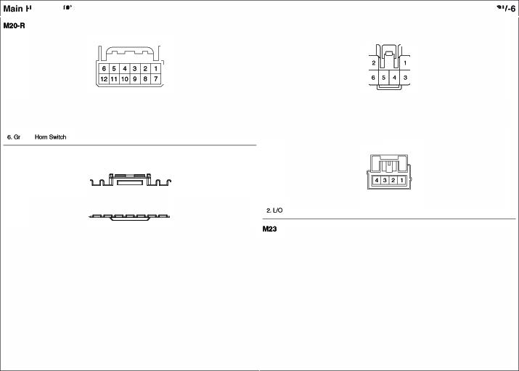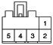

7.0 SCI.I•Real' Y'l'tipl!r&Mtch(INT

I.8' | Anleml | •.l | EMS Box· SENSOR1 t OA
2. | -<» | S.l | PCM OW.Line
3.8

. 6FEWl'l&le 81ack(Kn_090IL06FA

I.W US811PO•
\/00 9. - -

2.B US8·0(-) 1 .- -
 |  | D
'· "'°  �- | Ill.(•)  - | '·°'  5.06 | .,p.MdonBox MOOUlE 1 10A  ESC Mo<l.11&

  - US8 11.8 Ground (GIMl3)
••• US81\POO·GNO 12.- -
5.- - 13.- -
... AUX· AEF 1<1.l AUX·DET
7.y AUX 15.- -
&AIO l.l (•) 1&8' AUX·AIN

AUX& USSJac (WithllJV& Navlglllon
    - 12 Fema Iv,tilte( MIP_02s _W)
- lJO IU..(-) (ESCOffS-'ON
6. -

M2 DBCSw•ch
·6FEWl'l&le G1ay(KET_�06F_Q)
D
'· "'°  �- | Ill.(•)  - | '·°'  5.0 | .,p.MdonBox MOOUlE 1 10A  ESC Mo<l.11&
3.lJO | IU..(-) | 6. | (� s.ib:h 'CH  -

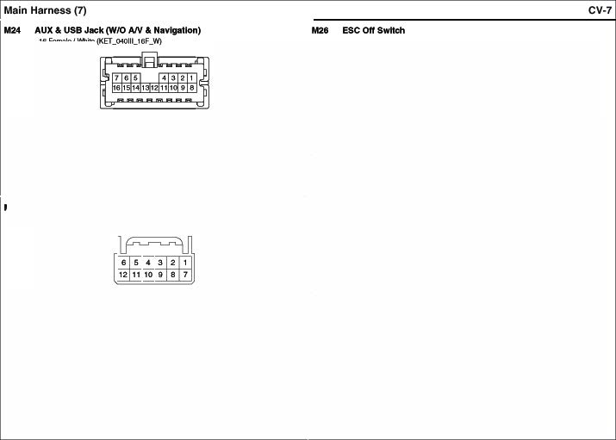

M28 .tWOLock SWitch
I.y | l .. | 7.8 | REF
2.81 | ... | 8.- | -
3. | D£T | 9. - | -
4.-  6.-  &AIO | -  -  U.(+) | 1 .-  11.- 12.B | -  -  Glound (GIMl3)

•6Fema &ot.wn{KET_090111.J)6 _SR)
D
1. A10 | Ill.(+) | •. y | CWOECM
�- | - | 5.B | °'"""(GM01
3.lJO | Ill.(-) | 8. - | -

  - 18 Hl 1T11'4tl �itlt ('KET..OOOll,.18F..WJ
06F.-S./�(KET

•

2I..uo- - 11. R

1. FK> ll L, (+)

.. -

3.R.<)
l.L (-)
12.w P•$MW'l!JIOlf $N WwlTl9f Rell!)'

13.
2-LIO llL. (-)
3.- -
s.y e.8

4. OtiYer SoatW.-mt11$...ct.
(IND GNO)
(""')
L P•$MW'l!JIOlf $N WwlTl9f Rell!)'

  - P....,S...tWwmotSMkfl (\ow)
(IND GNO) 1<.8 Gsouncl (GM01
.. - 15.- -
1. - - -
.. . | llP.Aildion6ox•O.UST R IOA | ''· - | -
•. w | OtiYer SoatW.-mt11Aiolay (�)  OtiYer SoatW.-mt11Aiolay (\.aw) | 18.- | -

M3 Qlove Box Lamp
·2Female/Black(AM

1131 ffontWipe Dell*' Swtlc (WIOSmart Key)
    - 6FernWIWJia(KET ..W)
1. FK> ll L, (+)

M3 Qlove Box Lamp Swttctt
·2Female While(KET_t87_02 _W)
2.0

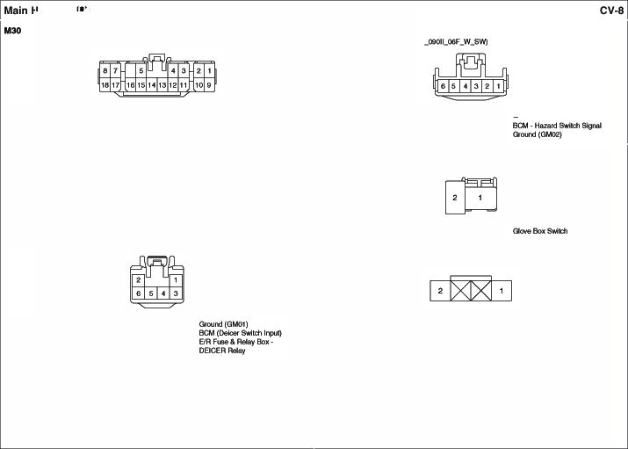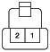
I. R.<) 2.8 3.UO

l.l.(•)
QOl.nd(GM

l.L (-)

••• S.W
8.0
  - Gloole Boxl.an1> 2.8
M39 ODO Trip SWlleh
•2 Femele Black(AM _OICM1_02 -8)

I.L 1115'1.rnl1111cu.. Mod9$Mkfl 2.8

<nund(GMo1

Qo..ncl (GM0

    - 16FemaleI Wl'llte(KET_0407_1eF_W)

1.L llP.Alldi:ln8ox•
POW OUTLET2 2$.A

3,9
··-

°"""" (G""2)

"0
2.G

C.CANLo
CC.A Migh

GrCUld (Gt.IO
�K..no.
Ev..,ara!or

  - llP.Alldi:ln8ox•
POW OUTLET 1 1 $A

M41·A A/C Conb"ol -lo (Auto)
    - 26Female I 'M'lile _W)
5.RIO
6.B
l.L.(•>
°"""" (G""2)
3."'
<.G

7.G
8.0.
k1IM:4oActlata(FJ9)
MocktActu&lof(FAJ)
P• f.SC111191'Temp.AcUD(F,fJ
OtiYefTemp, Aceuat::K (F CIU5Wf IonizerDiagnosis W/ln
$enSIOf (•)
A.rllDontSenriol"(•)
ll'l()lr�(•)
SUN(•)• OM1
SUN(•)·P�
ECVOul

M43- AJC COntn>C -...(-ij
•6Female While(KET_2SWL._06F_W)

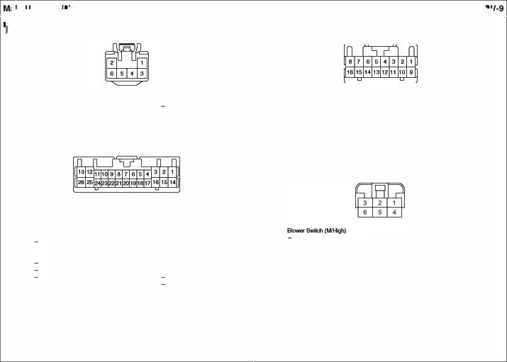
1.G llP.ll ncfonBox FIOCl.lLP IOA
2.0.0 U.(+)
3.0 llP.ll ncfonBox·MODULE 4IOA
4.Y Drive Temp Acllab (Cool)
£.0 Drive Temp Acllab (Watmt
6.-
7.A Mode (VENT)
... Mode�(D£F
··-
10.-
11. -
12. LIO I.I
13. B GtOW'ld(GM01)

...o

17. p
... .
19. p
20.Y
21. p 22 WIS 23.A 24.-
,. _
26.Go

Vte1(+6V)
Clusb'k:ri?elSignal
.,..AoUllor(FRE
.,..AoUllor (REC)
Clusb' k:ri?el°"911 Signel WP.b'lclion Box• AJ<XM7.6A Pas�TOf11>. AclUall:S (Cool)
Pas�TOf11>. AclUall:S (w.&m)
FET(Gale) FET(Dr�

S&l\SIOI' GrW'ICI

1 .G
2.-
3.B

Groww:I (GM02

•••
•••
...

Sbwer&Mich �) Sbwer&Mich (M,o\.ow) Sbwer&Mich (I.ow)

• 32Female I Y'l'rlile(KET_02£09_32 _W) • 18 F-emaral�tel)(ET_09025_18F_W)

I."'° U.(+) 17.0 WP.Mclion Box

MOOl.l. 4 10A
Aeer000t Speeket LH(+) 10.8 RearDoofSc:>eal<efLH (·)

- 2.8' �DoorSpeakerLH(+) 11.w FrontOoot SpelH
(-)

2.G llP.ll ncfiBox
ROCl.lLP IOA 18.- 3.R �DoorSpeakerAH(•) 12.l FrontOoot SpeQket AH()

Mode (VENT) 19.G
·
c.cN<i..,,

4.l Mode�{DEF) 00. c.cN<low
6. Ten'{) Actuell:S(Ced) 21.-
8.0 Ten'{) Actuell:S(w.&m) 22 GI ECV In
7.8 Na Actuati:s(FAE) 23.l ECVOUI
.. p Na Actuati:s(REC) 24.-
4.G Aeer000t Speeket AH(- 13.0 Rea --RH(-)
6.8 SPOtf'•$hlekj GrOU'ld 14.-
•)
8.G  7.Gr | SPOIF·OUT(-)  11PJunction8ox·a.USTEA 10A | 16.W  16. | SPO ·OUT(
.. ""'  ..- | llL. (+) | 17.L/O  18.G | LL(-)  ---

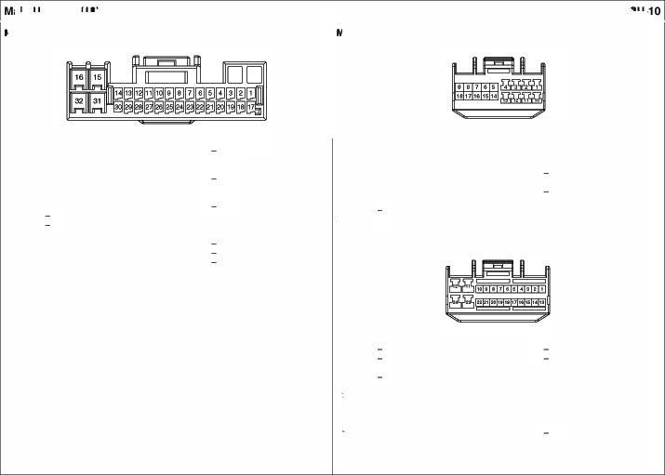- ..... Vtel(+6\1)
·
·
10. - .....
  - G Mode (Fifi} 27 LB ArnbiMl Serlsor(•) M45- A DIO
12.W | Ten'{) Actuell:S( FIB) | 28.-
13. Gr | Na Acb.lab:S(FJB} | ...-
14. p | 8i0¥fel' MW. 'ON"'Signal | 30 -
16. L  16. LJO | 8i0¥fel' FJB  l.l(-) | 31.GI  32. | S&f\SIOIGrW'll!  Glound (GJ4

•24 l=em /Wlltel)(ET_09025_2<1 F_W)

1.l 2.- | CANMig | 13.R  14.- | c.oNLow
3.- |  | 1$.-
4.l | AudioRomolltConni | 16.Bt | v.n..SPMd Signal
$.- |  | 17 .G1 | A\doFlemoMoConltol Gro.ncl
&.Y | useoc..> | 18.8 | use D(·)
 | US!W'OD•VOO | 19.8 | US&'iPOO • ONO
.... | AUXR,,.IN |  | AUXDET
••• | AUXGIO | 21.y | AUXL.,JN
10.A | VP.b'lction8ax• AUC*) 2IOA | 22.l  23 | M IC(• )
12.A | VP.b'lction8ax• AUC*) IIOA | 24.8 | -(GMO<!)

·2 FemaleI'f'*1w(FQ_Al(IL02F_Y_ll)
    - 8 l=emalalOretf(AUP_AU0t0_08F_Or_D2)

1,13<
..""'
ao
-­ ILL
s.er.v '"''°
7. LIO
8'd<·l-'>
'1 ..udanSox• AUDIO2 IOA ll.(-)

  - SASConlJOIModule 2.1> SASc.or.rd UcKllle
(181Sleg&Hlgh (lat Stage l.OW)

Pa...._ AJr ag#2
·2 FemaleIYdlaw (FCl_AKlL02F_YJll)
VP.b'lction8ax• AUC*) IIOA ...

Bio- Rele lllor(Man AIC)
• 4FernW/811ck(K£T...250 .Jl)
    - R
...
ae.
�y 5.-
6.-
7.-
8.G
1.G | SASConltol Moclul4t | 2.w | SRSCoc*dt.b::k119
 | (2"d- M;gh) |  | (2ndS-Loo?

9.0
10. y
WC WC('> AUXR_I
AUX�

Ell! A.n'lng Signal Al.Aoligh 5qlal AUXREF
11.0 l2.-
1a-
14. - 1S.G
16. l 17.GI 18.- 19.- 20.

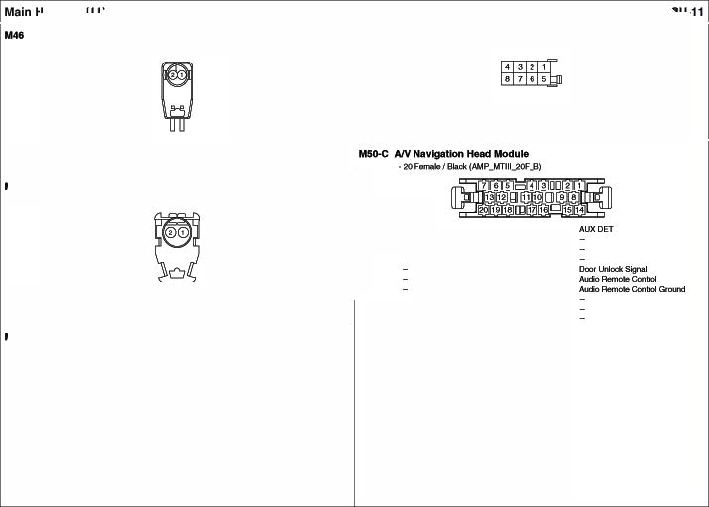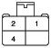

_.._
 |  | 3
'·p  2. | ·- """"'(»loo?  .,,_......._) | 3.R  4.l

.24 Femele/Wl'il&(KET_02S_PC8__24f'_W) • 10 F-emara/�te l)(ET_090l._1oF_W)

1.w SPOIF·OUT(•) 13.y Real' ViewCem«a (B+)
2.G SPOIF·OUT(-) 14.YIB Real' ViewCem«a (GNO)
3.8 SPOIF•5rlil!lcl GIOW'ICI 1..R Real' ViewCem«a (C'\IBS) 1.8 Grouw:I(GM02) StM Flel"fCcNd

4.- - 16.M Real' ViewCem«a (VGND) ..8
£.- - 17.- - 3.
"'°"""
-
(G'-"2) IGNt Relay Conlrd
IGN2 Relay Conlr

<.8• NEVI Voio9(•> 16.y NEV Voiolo (o) ..- - ••• ACC Rel"!CcNd

7.- - - $.- 10. R ll'P.b'ICtionBox
-
POM 1SA

a- - 20 NEV
··- - 21.- -
Voiolo
(GNO) •

- 22. - - M52- PDll (Wiii\ SmortKoy)
1 1... - 23. -

  - 24.R CANLow

llSl·A PDM ReloyBox(WithSmort Koy)
    - 10 FemaleIv,tilte(AMP_092S_10f_W'J
- 20 F-emala/Wllte l)(ET_CMOll_ 20F_W)

1 .w llPJonctlonBox•ua:M.U 21OA 11 .l 8-CJH """
�Yl8 F08 HolctEw•It.IMO.Cfoc* 1�0l8 F<e..
1.p PW•AOCRelay Control 6.W ACC 3.WIS F08 HolctEw•It.IMO. Oita 13.- -
2.- - 7.P EIR Fuse ANyBox·IGNI 3C>A <.UO WMellon Box·AU01021 0A 14.p ESC(Whoel-S..-....1.-.UI)
3.8 GrOU'ld (GUOI 8.P tGNI OUpl.C �- - 1�"6 -{SlwLEMSI

4.R PD>4• IGN2 RNyCtiMd 9. -
-
  - SS88W1 16.Wi9 F..RPM

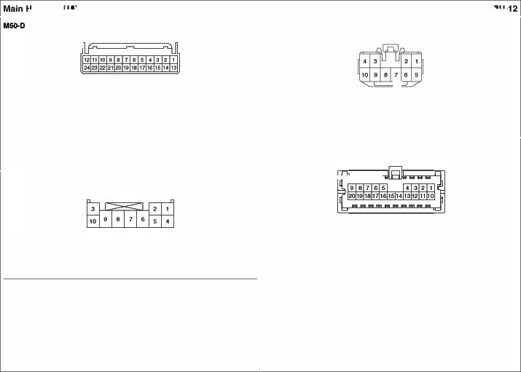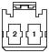£. 10.W PW• tGN 1 Relay Control 7 .8/0 SS8LL Ground 17.y SS8 IND.Nrbel
6.0 SSBm.Gi-een 16."6 SS8 IU.. P-owef
US PDM Reloy Box (With Smort Koy) •. o WMellon Box· MOOll. s1!>A 19 .P'8 FC8Kc*lerLL
10,A S.CANLow 20."'° llPJonctlonBox•
    - 2 femab/81ack ��F_B) SMARTKEVtM

1.L tGN2� 2.R EIR Fuse RNyBox·IGN24C>A

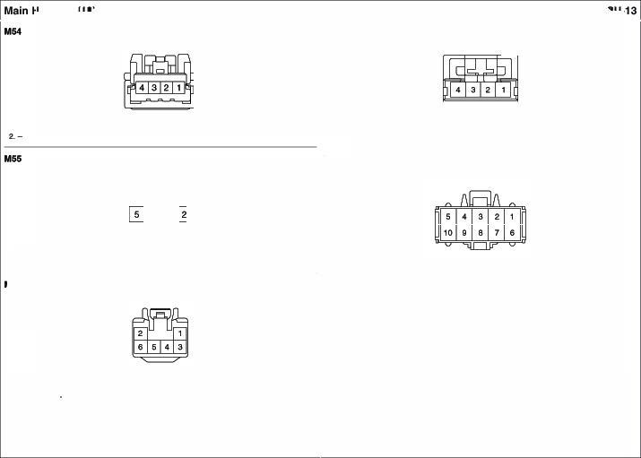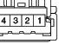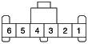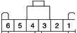·" Ferntlkl/wt'ite (KET_O«>IL04f_WJ •4Female _8_0t<Jit

  - AF_c:aA 3.0 ll .Ancllon Box AOOM LP 10A I. - - 3. -
- 4.8 Ground (GYO'I �· SmartKeyCoo1re1 Moehle 4.l StMl1Key Con•Ol"6Cd.lle
�A...arwiaf1 Signal) (InteriorAll lenneII Qround
Rheo-
    - 6fernekl/wt'ite (KET_91A_«* _WJ M6 SI.. Slop Button Switch( WithSma Key)
• 10F�/811ck (Ml.)(..FIT..u:F,.B>

I.l!O l.l.(-) 4.l "•"""""
2.B GtOW'ld(GM 6.G OCIM'I Swi
3.""' U.(+) 8.- - 1 .w sse 6.l ll .MdonBox SMARTKEY 10A
�l WMellon Box SMART KEY tOA 7.l SS8SW2
Aee Oeloggw Sw•d' 3.y SS8M>.Antlef e.o S SSN>.G 1een
6femaleIwtite( KET_090IL06F_W) 4.8/0 SS8LL Ground o.VO LL(·)
�IW SS8 IU.Power 10. -
•

I.A.<) | ILL .. ) |  | QOl.l'ld(GMC:rl)
2.e  3.VO | °""""(GMOO)  ILL.C·) | 5.W | 8CM(FIN O.f0!!9' 1Switc  WilhSmlrtKey • | l'lM),
Fron W1POJDoa SW ...,._.
6.G llP.Alldion 6 oo1• HTO MIRR 7.SA

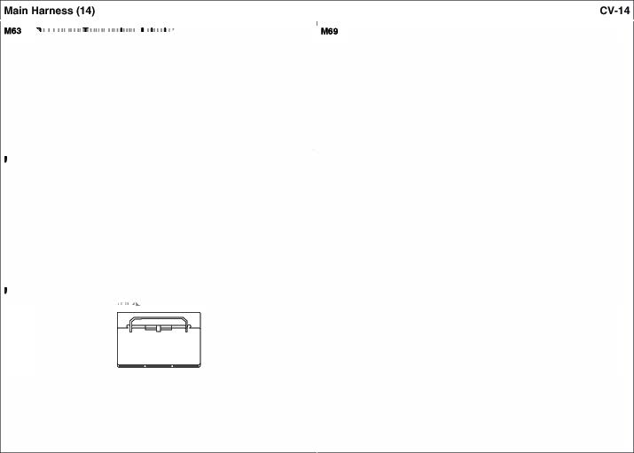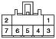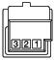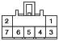Tlltalol.Mnp
- 1F...-/Sllck(IOM.,.CO FL,0 ..B) •3fEWl'l&le 81ack(AM _MOS_OOf'_8_1)

'·- - 5.9' NC°""'�-... (lhel)
'·L | W�lion Bo | IQA. | 3. L | SAS Conlr | Moch•
2.8 | G-ciuncl (GMJ4

2.- - 6.W NCc.ntt� -...(FA!)
3.Y NCeon.olMO<U9 ( Cool) 7.'" NCControl Module(SeneofONO)
- NCeon.olMO<U9 (Warm

  - 1FernW/811ck(KUM.,.COFL0 ..B)

1.- | - | .. "' | AICControl Module( S&nsotGND)
2.- | - | 6.W | AIC Control Modole(FJS}
3.0  4.Y | NCCtinliolMocUe(Warm  NCCtinliolMocUe( Co)ol | 7.& | AIC Control Module(Vtel)
Tire Pree8u.- Moolloflng U-
• 12 Hl 1T11'4t Grll!Y CJAE... 12F..Gr).

l!lrnmrnrnm
�[j)�@][!]UJ

°'°"""(Ot.I02)
'·R | llPJl.SICl!on Box•TPM | 7.sA | 7.GdO | l'P.Ainc*onBox·MOOULE 110A
2.0  3.8 | c.CON..... |  | 6.0  ··- | C.CANLow  -

4.- - 10.- -
5.- - 11.- -
6.- - 12.- -

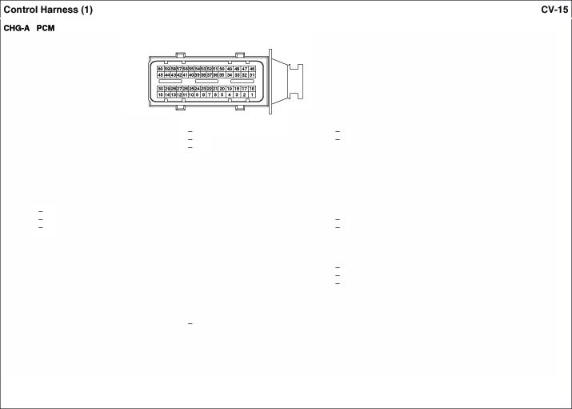

·eof«nekl/Elack(AMP_ECU_eof_B_R)

l.G | VIWI Sma Key IG Ceil14 Ccftrd | 21.- |  | 41.-
2.8 | WKJSmalKey·IG Ceil11 Ccftrd  1"1ilion Coil �Gtound | 22.-  ""· - |  | ....-  .aw | Cluli::fl &Mtch
3.L | NT LP_VFS | 24 | Y'M'I Srnar1Key EIRFute&Al!lay | u.ue | BnMTest&Mtch
4.G/8  6.W | Al·l EC_VFS NT•3&FLVFS |  | Boit (AT... PIN Aday WKJSrnar1Key EIRFute&Al!lay | 45.L  .... | VCM (DCUolor..1)  WiflSma Key• IGH..Col 13Cor*1:ll
6.BIO  7.GIO | NT•k'lp.l Spel!d�  NT.�SpeedS... pptf | 25.R | Boit (Star1 RNy)  NT •Posilicin SMdlCode(S2 |  | w.ioSma Key• IGH..Col 12Cor*1:ll Air•5°"noid Power 1
6.W | NT•k'lpll Spel!d Signal | 26.G | NT •Posilicin SMdlCode(S3) | 4&0 | Air• 5°"noidPower 2
9.L  1 0.- | ""."'- -""""' | 27.Br  28.AIT | NT •Posilicin SMdlCode($4) | 49.G  50 | Air·EMSSox•TC 1 IS.A Air EMSSox•TC 1 IS.A
11. - |  | MIT. | Rl8 | 51.-
12.- |  |  | StartCM!r'T'-"I (POM) | 5" -
1 3.L | ""1i:N!r ,,, IJ1)U | 29.G | Stake�Wk:h | .._.. | A/T•OIT0111>- Semol" (·)
14. | �loac Signal From Altemalot | 30 | CluiteCcnlrd SMi::flSignal | .... | A/T•OIT0111>- Semol" (+)
16. B  18.W | CnjsoControl SMdl GrCU'ld VIWI Sma Key IG Ceil12 Ccftrd WKJSmatKey·IG Ceil13Ccftrd | 31  30.G | Y'M'I Srnar1Key IGN.CCII�I CtirWd WKJSrnar1Key·IGN.CCIIitl4CtirWd A/T ·SS-8 | 56.G  sa  57.- | A/T• OCP+ High A/T•OCP+CAN Low
17. 81  18.P | AfT•UCl | 33 p  34.8 | A/T ·SS-A  A/T GtOW'ld( GtG:l6) | sa  se
19. G | NT•Slliftl.O(t(Solenoid | 36.8 | A/T GtOW'ld( GtG:l6) | 00 | VCM (DCUolor
2Q. | AfT•OD_VFS | 38.P  37.Gr | NT •Do""1 sr.in  .vr ·UpSN
 |  | 38 | A/T •Sdeol �tch
 |  | 39.-
 |  | 40.P | A/T •Posilkin SMdlCode(SI)

    - 94FemaleI Biid(AMP

1.8  ••• | GrCU'ld(GHG<6}  EI Fuse&Aday Box ECU 2 7.6A |  | "'-  27 | l�eok>r 13Control l�eok>r NControl |  | 51.G  ...G | EMSBox SENSOR415A nPS(S;gn.J) |  | 76.W  n.G | Batk!ry S&f\SIOt{l C-CANHigh
3.8 | GrCU'ld(GHG<6} |  | 28 | l�eok>r 12Control |  | 53.G | IAT ....... |  | 78.0 | C-CAN""'
4.W | EM Box E� Col* | RNy | ... - |  |  | 54 APTSigMI 79. -
... | GrCU'ld(GHG<6} |  | 30.l | UA S&l\SOI Sl.()pt/ |  | 56 - 80 TPS. I sq.al
6.G EM Box TCU 1 16A 31.l/O UAF.t.lA Sensot Signal 56 - 81.-
7.- 32 TPS.2�nal 57.G APTC>ou-d 82.0 APS. 1 Signal
8.- |  |  | 33.Wf8 ECT Signal |  |  | 56 - 83.R |  |  |  | CM | tt GrCU'ld
9.0 | FuelT4"* Level S&nder |  | ..... Knoc S&nscsGIOW'ICI |  |  | 59. WJB TPS GrCU'd 84.
10.- |  |  | :lS.lJO APS.2Sip |  |  | eo."' | APS. I &#1)' |  | WJO
11.- |  |  | 36 APS. |  | 2Sl.()pt/ | 81. y | APS. I Gtound |  | w | 02Sentot (Oo ...n) Signel
12.y | KnockSentot Signel |  | 37.Wf8 CM |  | lt2Ground | "' w | CMPS11 Signal |  | Wil'ISI.I.
13.8' | APS.2 Glound |  | 38.- |  |  | 63 y | TI' |  | ... | 02Sentot (Oo ...n) Signel
14.l | ECTS.,._ |  | 39 a< |  | GIOW'ICI | ... l | EMSBox Eng | Col*ol R!l!ay | ... . | 02Sentot (Oo ...n) Ground
16.y CUPSf2 Sign .. . Vdlide SpeedSentot '6 EI Fuse&Relay Boit• 86.. WJB E� SpeedSignel
18.- 41. - CIF., lORelay 87.81 E...SBox •AKXM �y

17. p OCPSSignel
02 (IJpt (VJI '8.G cwr�Col*dSign 1 ... ,,. EIAFuse&ANy Box•

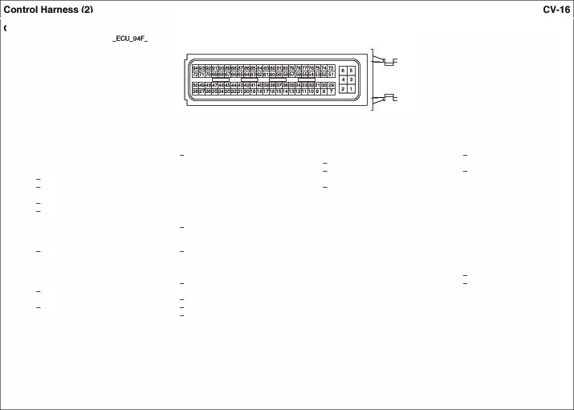18.W 02 Senses(Up) 43..Wf8 Serlsor Stipp!)' 67.G PCSVCoobol CIFa .. R&y
....
  - 02 Senses(Up)(VJf 44. VCl.I (FJB SensesGND) t.8 Viti cwr�Col*dSign 2 89. -
2Q.O 02 Senses(Up) 4S ee BU'O MMO IND 90 -
21.- ...l Alletnall:S(COM) 70 EM Box � Rl! 91.GI' ccvee....
.... VCM(F.8Sentot PWl'lerlllo-� "· - 71 ETCDCMolot I 92 YIB E�Old
23.- 48. 72.R ETCDCMolot2 93.G 02Sentot (IJpt He6b
... . EI Fuse&Aday Box•Star1 Rl! ... - 73... nPS(GN 94.Y 02� (Oo ...n) Meeks
... .. lrjec:ti:s11 Co!W'ol 60 Va. abb .,.. 9f*rn 74.B TMAPIT'MAFSerlsorGJOIRI
7E.l MMO DalaUwJ

ninNxte Rlftgt! SWl
    - 10 Femele/Bi&ck(KET_a509WP_1oFJ3) · 18Feme.1&/81ack(FCLMULWP_18f'_8_1)

-
-
I.- | - | 6.-
2.A  3.- | --·-�(S2) | 7.-  6.0

PositionSwitchc.oda(S3) I. - - 10.GI PCM(SolenoiO� I)
�GIB PCM(EC_VFS) 11. p PCM

..� EIAFU98 &Aellrf8ox• TCU2 7,SA. 9.1> PositionSwitchc.oda(Sol 3.GIO PCM�--) 1�G
··- - 10.P PositionSwitchc.oda($1)
�l | PCM�-"'9""> | 13.. | PCM(Oil TM'() &!nsot (..))
5.0 | PCM(Sdenoid Power2) | 14.BIO | PCM
8.W | PCM(36FLVf | IS.- | -
7.y |  | 18.8< PCM (UD_VFS}
8.W  .... | PCM(I.....--  PCM(QI Ten-p Serlsor (-)) | 17.l PCM{1.P  18. p PCM(ss.A)

CHG02 AmblontSonaor
·2 FemaleI �(KET_SWP_02FJJ}
(26_VFS)
PCM(SS<!)

CHG06-1 OiiConifol V""°t1
•2 F9n#e/Bl1ck(KET_«K>W

l.UB NCCtirWdMocUe (SeMor (+)) 2."' A1C Control Module
( S&nsotG rW'llf)

llett..y SenM<
•2 H11n114tl Btac*(PMP.)l.CPWP

1.0
PCM ®2.w EMSBooe:· Seneot1 IOA

CHG06-2 OiiConifol V""°'2
•2 F9nale/Bllck(KET_«K>W

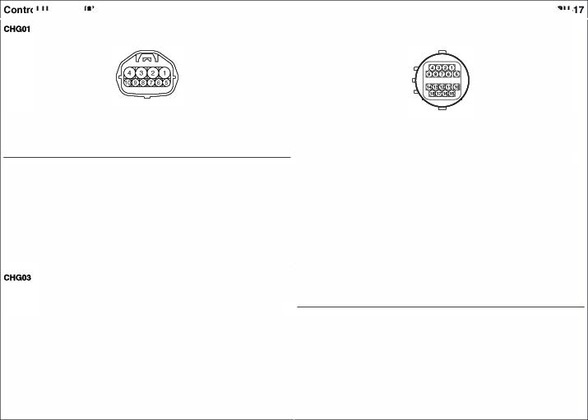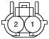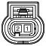
I.W PCMl\.IN) ••• £11=1 FU50&Reil 9olC•
9+ SENSOR IOA.
- IS PCM ®2.w El.tSBooe:· SeMOt IIOA

· 3 _Gr_3)

CHG EngfnitCOoten T..,,pwature Sln:s
  - 4 F-emara/E!ladc(AMP_EJWP_04F_8)

1.l
2.
PCM(COM
Char99 IND., Diode
3.W
PCM(FR)

1.8
�-

Qou� (GHG0

CHG07
Fron w_,.,Mo4
- 6 Female/Blade -8)

CHQ13-
C1m Po--ti
- 3 Female G'ay(Sl.l.4_090ll' _OOF_<lA_A)

1.G
2.P
Fron W�Sv.ilc:h(LO •••
Fron Wc>e'Sv.ilc:h( HI) 6.L
- ll ncfonBox·WIPER FRT 25A
8. -
Glout.i (GHG0
EI Fuse& AdayBox•
WIPERFRT LO Rela

1.G
�·
EM Box•SENsa:t1 10A 3.W
PCM(SEl'l90fQouncl

Ignition Loc Swllch(MIT, W/OSm Koy)
  - 2 H:lmale/'Mllte l){ET_OOOll_02 _WJ.)

CHG13- Clmahaft Postion Sensor12
    - 3 l=emale /Gr (SLl.L090ll' _03 _GFLR)

1.B QOW'ld(Qt«lOI 2.W EI Fuse& AelayBox• Sta Aellrf

  - EM Box

•SENSCR 1 10A av

PCM (Sonoo< Bllo>"l

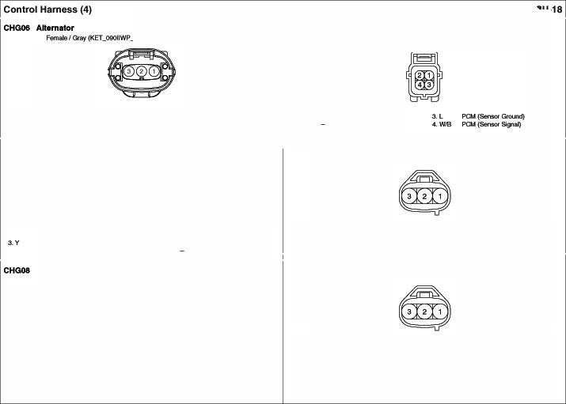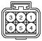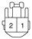�- PCM(SerlsorQourd

    - 3 Female/Blade (A _._.l)T ooF_8_S2)
CHG17 Oxy1 S.nsor(Down CHIO SUI.E
      - 4MaJe/El:ldc(KET_SWP_04M..8)

1 .0 .-16 EMSBox SENSOR 1 10A
2.0. PC ts-<l<ound)

3.P
PCM (SeAEIOf $9'1al
1.P PCM ($Gn50fQo.n:I) ZW PCM($en5otSi'11al)

3. y
•.O

CHG16 011 PrMeure Swttch
·1 Hilm#e/E!lac* (KUM_NMWP_01F_8)
CHG18- '90llonColl'1
•2

1.YIB OilP feSSl.l'EIIND.

wtltl...0.I$minIC9f
1.8 PCM
WJO1tAIO./&m.rt K.,-
  - 0 PCM

CHG16 Oxy -- (Up)
    - 6 Fem•ler.d; (A .,.MTil'WP_06 .Jl)
2. P EM Box ECU 1 20A 2. P EMS 9oot· ECU 1 20A

CHG18- lgnllonCoU#2
•2F-emale/Blac (KET_090WP_02FJLL:))

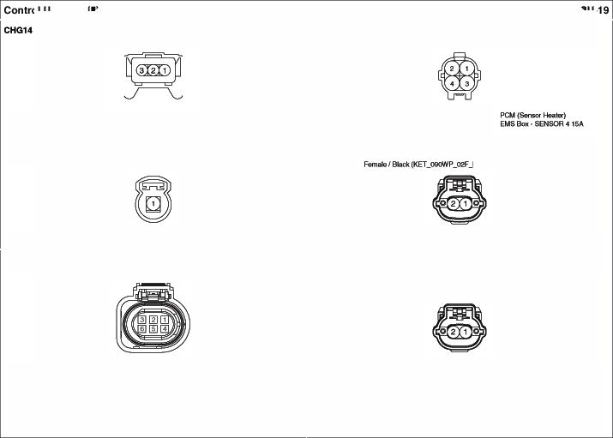1 .0
2.0
3.W
lambcla6en&or(V lambcla6en&or(VJ(I
..-s.n.o.(VJP)
••• 5.0
•••
EMS Box SEN90A-4 ISA PCM(......U1> S-m)
lambda6en&or

Wittl&llllO./Smtrt�
1.W PCM
1-l EMSBox ECU I 20A

W./O1...0 / SmartK.,.
1. A PCM
2. l E>.15 Boll· ECU120A

C. ...,.Purgeieont SOienoidVtt\11
·2 NlmeJe/Blacl< (l(ET.OOOWP •2Feme.1&/81ack(fK0_1sowP_0'2 �-1)

'Mttl IM ISmall Kev 1•• PCY

WIOMl.0,/Smer K..,
1.W PCM

1 .w EMSSox•SENSOR I IOI\ 2.0 PCM

2.0 EMSBox EOU 12M 2.0 EMS Box ECU120A ETC Mo4or& Throttle: Posttk>n senso
•6FemaleIBlack(AM J4QSWP_06FJL1)
CHG18-4 lgnMlonCOii14
·2NlmeJe/Blacl<(l(ET_OOOWP_02F_8J.3)

'Mth IM ISmerl Kt¥ WIOIUMO./$mw1K..,
1.WIS PCJ4(TPSGrClllnd ••• PCM (JPS I Signa9
�y PCY(T1' &.""' 6.l PCM (JPS 2 Signa
�w PCJ4(ETC DCMob 1) ••• PCM(ETC DC J.lob'2)

1.0 PC 1.8 PCM CHG23 KnockSensor
2.W EM Box•eou 12M 2.W EMS Box ECU120A
•2 femaleIBlack(PK0_ I)

CHG19 c-
• 2�/ Slllck(,,._X...OlilOCIGAA,..02F..B)

1.8<
2. y PCM(SoenscsSignal}

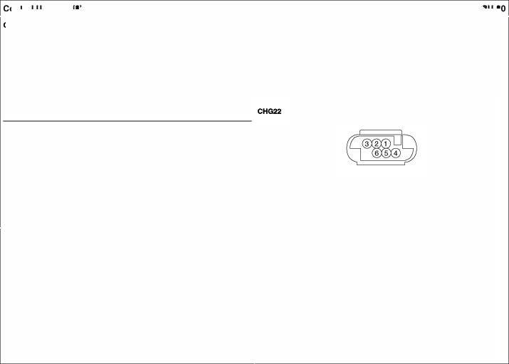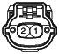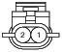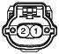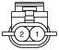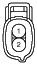

1.8 GrouM(OHOol 2.0 EMS Box ECU120A

MAPSensor
·2 NlmeJe/Blacl< (l(l.IUIDWP.°"'JI) •<4Feme.1&/81ack(MI _JPl' _<>tf'_8_90SH

m d•I2b
1.l EMSBox· SENSOR31M 2.1> PCM

CHG24-2 lnjoelO<12
•.VO PCM(M�/MfJS' Sensor$9'111) 3.0 PCM (I $Gn50f)
2.l PCM(MAP S..-$"""'} •.8 PCM (TMAPfT MAfS..-°'°"""

·2 NlmeJe/Blacl< (l(l.IUIDWP.°"'JI) CHG28 -1.a

m
I.VOEMSBox· SENSOR31M 2."' PCM

CHG24-3 lnjoelO<13
·2 NlmeJe/Blacl< (l(l.IUIDWP.°"'JI)

8CM(Tisn LalT'P)
2.0 VP.b'lction8ax• IPS

'1P..udanSox IP 1 (T&il�
& 5.8 (ft.nj(G><G02)

<-d.....,High) <5, (ft.nj(G>!G02)
m
3.G• VP..krlction8ax• IPS4
(HNdl.Jlq)Lo

  - EMSBox• SENSOR310A 2.l PCM Heed Lemp RH
    - $F orrat.I 11ck(KET.,JIEAOt.AMP,.06F.,JJ)

CHG24-4 lnjoelO<t4
·2 NlmeJe/Blacl< (l(l.IUIDWP.°"'JI)

m

1,W ec (Tuml8fll>) •. y '1 .b'donBox-IP (Tall l.ar'nf)J

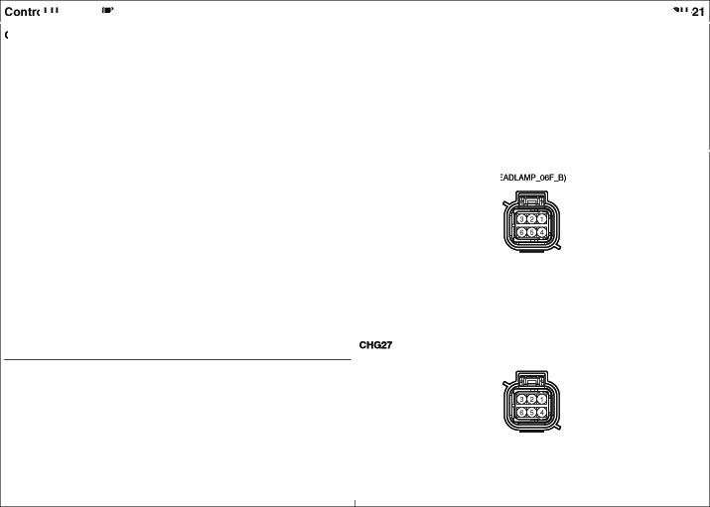1.0 EMSBox• SENSOR310A 2.G PCM 2.<¥8 llPJunction8ox• IPSI 5.8 Qouncl (GtlG04)
(Heed....., High) 6.8 Qouncl (GtlG04)
3.G• llPJunction8ox• IPS0

(Heed....., I.Ow)

A/C Compruso Fron Wtp O.lcor
•3Femtl/lle Qey (t(L.M_NOWP_oa _Gr) •2Feme.1&/81ack K'UM_NMW_P 02F_8)

A/ Pre...,..Transduce CHG34l Clut SWleh(MIT)
I.y | EMSSox•NOON R!!lay | 3."' | AICControl '4odole(ECV IN) | l.G EI Fuse &Aday Box Deiol!rAday 2. B
2.L | NCCcnlidMocUe (ECYOUT) |  |  | l.G EI Fuse &Aday Box Deiol!rAday 2. B

•3Femtl/lle Bi&c (KET _8) •2 FMWJA& While(KET..2SWL02 _W)

l.G PCJ4 (Glow'ld) 3.WIB PCM (Stipp!)') 1.8
§2. w PCM

  - 'PCJ4 (Signa "'9 WithESC
·ESCMCKUe

Fronl Whele Sensor RH CtlG3 Baci<-Op Lamp Swttm(MIT)
•2 Male/Blaclc

    - 2 Fem Elk
(A ..WP

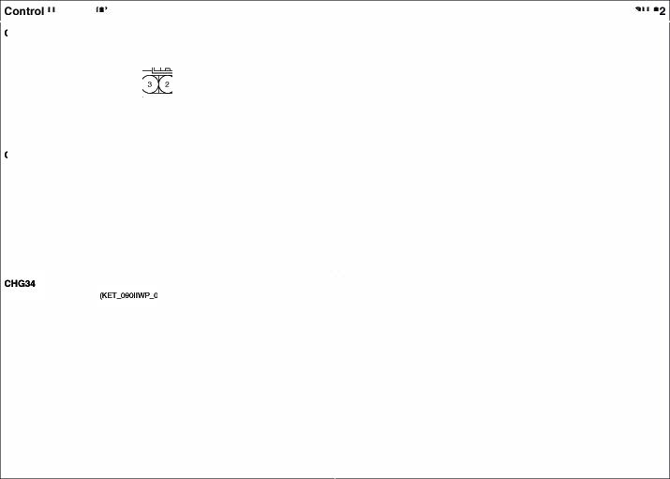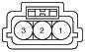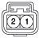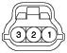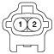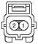

  - ESC ,._(SIG) 2.W ESC-(VCC) 1.8 Gtciuncl (GHGCQ} 2.w IPSCOl*tllt.b:llo:kl

S1opL-Swtldl
    - 4 FemaleIWhilll! (KET..2£0L,JM

_W)

3

· 38Fem&l/81ack(AM _A8S_38f'_8_A

PCM.ESC_oec
W,luw::.aon Box-MOOULE 110A

Soop.......l.HlllH. 4.US PCM ESCMoch'9 l.W
�-
IAl!li Fuse•ABS 1 40A 20.y Rea 'M'leelSensorRH (SIG
- 21.S. frClll'l 'MV!ll!I S&nsol'RH(SIG

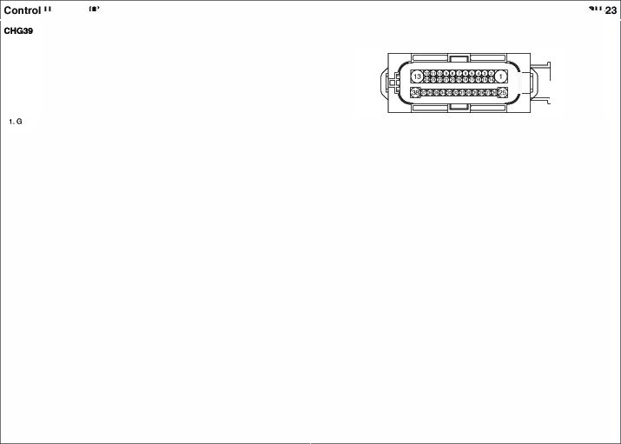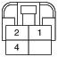Hig�J.bt'll9dStopLa
Smwl... C.M- �-
2. EIRFUN& RelayBox • �o
STOP LP 10A 5.-
6.-
7. -
aWIS
9.l
10. QB 11.UB
12. y 13.B 14.0
16. -
16. - 17.P

18.0
19.A
- 22.&fB FSC:C...d MocUe • Parlclng
YNRaleSerlsor(� --
- 2�G Slop La111>SW::fl
- 24.B YawRab &!r\sol(CANlo.)
- 26.l M• Fute·ABS2 4C>A
oe Rl!lavC:C.W 26.G c-cANHig
8fake SWilc 27. - -
esconSW::fl 'ON' 2a• PCM (Wlle&I Spl!ed&!r\sol YNRaleSerlsor(Grouv;I) """'"' F"l YNRaleSerlsor(CAN Hig 29.GI EIR Fuse& Rela Box •ASS7.&A
30.- -
C-CANL.ow 31.G frClll'l 'MV!ll!I S&nsol'l>I (SIG
- �l Rea 'M'leelSensorLH{SIG)
- �· Rea 'M'leelSensorRH (VCC) PO (Whed�Serlsor 34 frClll'l 'MV!ll!I S&nsol'RH(VC)C
�RR) 36.WtB MIT •Cluldl&Mich
Fftll'lt wt'll!d� LH(VCC) 36 D8C Rela 'ON'Sgna
� Whol! S&f\SIOtLI-I (VCC) 37 D8CSYMi:::fl'ON'
36.B Qound(GH

. 3 Female/Blade (AMP_SPTWP_ooFA
•2Fem&l/81ack(AM ..JP1'_02f'_8_Q.IP')

I.A EIRFuso &Rela. Sox 3.8
CJF/JH ....Flelll!Y
  - EIAFUN &Flelll!Y 8ox•

Fronl Fog Limp LH
• 2F«nE11E1/Ellck(KET 11r1N -�_8)

'·L VPJlSICllon Box• IPS6 2.9
Gsouncl (GHG02}

-(Gt<Go2)

1.8

CHG48 Bwgt A..rm Horn
•2FMWJA& 81ack Ml.X_02

    - p EI Fuse &Aday Box•
S'AHornANy

_B_FILT)

2.8

CH0"4 Ac1

..ol

Pollllon -
CHG47 Uuhlpurposo Ched< Conr

•6 Femeia/Bl&c _Od_8)

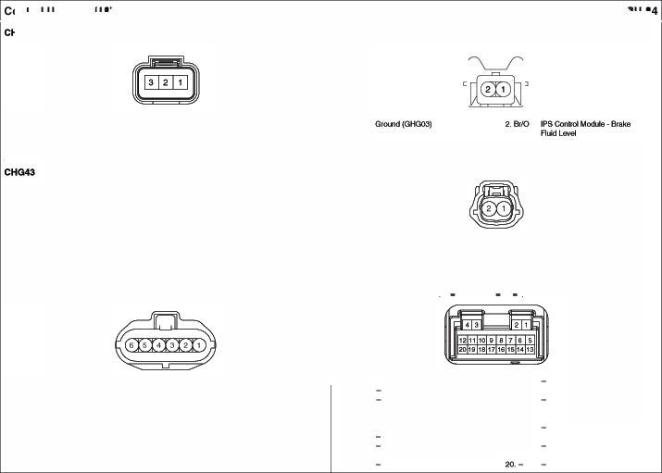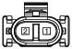
1.L PCM 2&1Wf)
2.0 PCM(APS 1 Signal) aLIO PCM(APS2 Signal)

•.<>
5. v
6.9'

PCM(APS PCM (APS 1 G1CH.Sld) PCM (APS 2G1CH.Sld)
1.8 Grouw:I (GHGOZ) 11.-
,_ ....
a-
••• MIJ1i F1.M A8$ I40A 14.0
�8 Grouw:I (GHG0
&.G CCP.C l4!f! 16.-
7.- 17.0
e.
9.G CCANH9'1 19.W
10. -

Ml.IiiFUN• A9S240A

CCP-CAN
EIFI Fuse&. AiokyBo •ASS7.$A

c.c eocttK...i,..

·2 FemaleI Bl(K
OOOllWP_Ol2f_8_.ASM •2 M•ISlk
(KET,..O/ilOWIP

  - G1ouod(OHOo< 2.A IPSCofwotMocUEI 1.0 ESCMoch (SIQ) 2.0 ESC Module(VC)
Hom Reer Was Motor

•2Femtl/lle Qey (t(L.M_N _0'2 _Gr
    - 2F-em /Blld (KET_090_02FJL

1.G �Fute&Rl!layBox • HemAday 2.8

CH06 E-..Ollluzzw 1.8 Grouw:I (GHG04) ••• RIN W,.$1war $witctl

·2 Female I Bl(K
OOOllWP_Ol2f_8_.ASM
CHGS Oxyiien -r(Down)(WHh SULEV)
•" Female/Blad; (t(ET..()lilrOlrNP ..B)

1.8 -(GHG<lO) ••• Smaltt<.,,.Qnd MocUrt

Fron! Fog LampRH
1. 1lbl) | PCM($en5otSi'11al) | 3.0 | £M$ BoK•SENSOR4I$A
Z P | PCM($en5otGrcwd) | •• y | PCM($en5ofHH1Gr

• 2�/Slk
(KE ..t !OW ,.OltF.,.B)

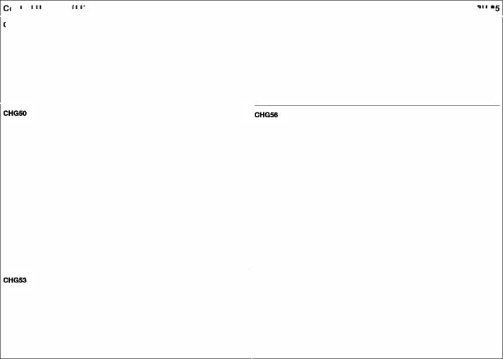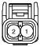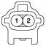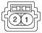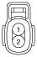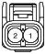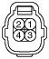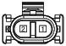

1.L VPJ� BoK IP$6 2.0 G-Ol.l'ld(GH G04

·10Fend& Whlle(KET_�IL1<:*'_W)
•3FemaleIBlac (KU>A_NMWP.J)G _B)

I.- 8.W
2.8 "'°'""'(GHGOO) 7.P
3.G/8 VPcsifcin SM 8.-
4.WJ8 WJl#IO'lion Box•TPMS 7.&A •••
··°' 10.G

CHGS7 Fron.I Waa Motor
• 3 Female I

......"""""
0-SNl

Glound (GHG03}

1.G1 Eifl M&AelQlf ox· TCU 3.Br

CHGIO Va-� llOllon Actual0<

•6 Female/Blac (AMP_.FT_OSFJLSFT)

•••
•••

CHG70 Varfiab'8 lntak8 UanWokS Verv
1.y
�· 3.WIS
PCJ4(FJB S&nscsGND) •. G
PCJ4(FJB S&nscs �Mebf) 6. l

S f«nete (CRosf0 1)
PCM (DC"'3tor� +2) PCM(DC"'3tor� +1)

- 2 Fem•ler.d; (AMP...EJWP

FfOl"I(Wlpe Switch llPJonctlonBox•WIP FRT 2SA BC14
•.l
- y
Frcnt�Moeo

., �Box·WIPE FRT2SA

  - 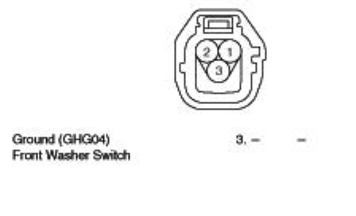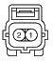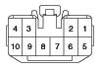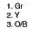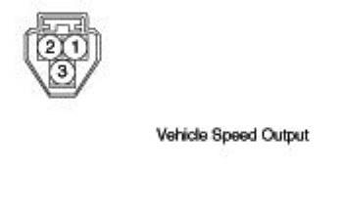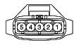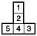Gr.V EMS 9:nc•SEHSOAt 1OA. 2.w
PCM

4 F-emaia/NfA(CAo4Foe8)
Blowo Re ay
•4F«nElle/f* (CRo4FOe6)

� �

1.l EJRFU9E1 &RelayBox· C/Ff.H40A 3.C> PCM (-yItConrd) 1. R IAl!li Fuse BLOWE 40A ae Qound (GHG02)

  - Coing
Fan Mot •.<> E/ N..ee& AefQyBox• �· Blowes Mok>r 4. Y/O l1P.bdonSox·MOOLl 410A
CIFAH LOAefQy Al.AoNC• VPJl#IO'lion Box
·NOON 7.5

CHG9 Doic.r-.,

4 F-emale /NI (CR04Rl86) CHG96 Hom Re ay
.4f«nete/f* (CRo4F086)
�
�
1.R EIAFuse &ANyBox· Cleic$'IS.A 3.l FSControl Modi.ff!

2.G Fron W�Ddi,
  - EIR Fuse& Ada Box• 1.G EIAfute&Rl!layBox· HORN16A °'"' tb SWilc

Fron W�Ddii:::ef SWilc Cleic$' IS.A �G - 4.G EIR Fuse & Rela Box •HORN ISA

CHG9 ATM PIN Reey(Wllh Smert Key CHG9 CIF LO Re ay
    - 5 F-emala/Nf (CAo5Fo 1) •4F«nElle/f* (CRo4FOe6)

�
1.p llP.Aildion6ox•START IOA. 3.W/O Elf! fUM Rela 9ox • 1.l EIAfute&Rl!layBox· CIF 40A ao PCM (Rl!l LO CcrWof)

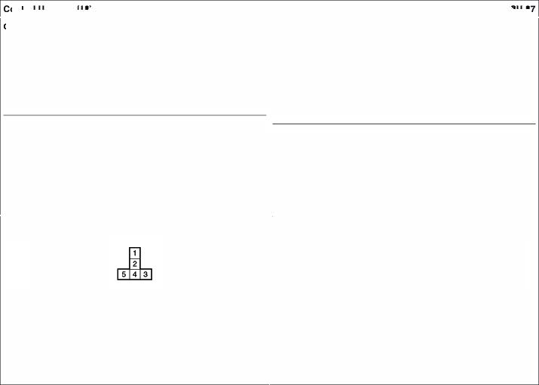PCM(&art °'9mn) ECU27.$A �w Cong
••• EJRFUM &Rela Sox S1art Aiolay -
5.W PCM Aely �
fan Moeot .. "' BIS Box· SENSOR4ISA

· 4 HiwnaJe/Nf {CAo4Foe6 · 4 f.emale/Nf (Cfl04Foee}
� �

1•• EIRFU99& RelayBox· 3.G'O IPSCcwWol MOCUEI

WJO Smal Key With Smer Key ARHTO.....
E/Ft F\188& FteieyBox

I.A EIRFU!l&
&Ael& Box·tGN240A I.A EI Fuse& Aela Box• IGN 240A �G "'"""""'Box •OEJCE ISA

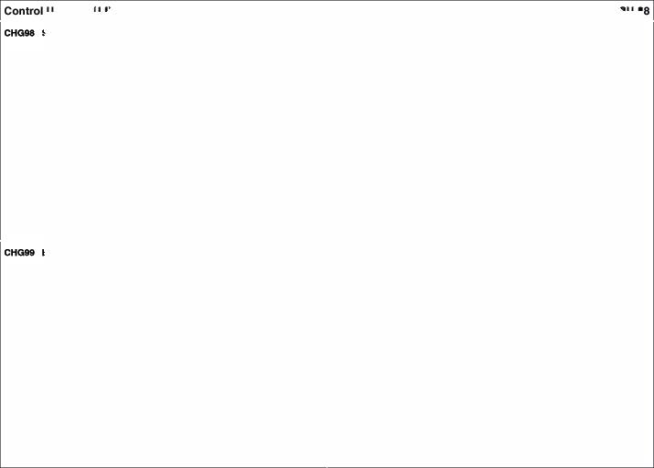••• Swt ••• SlartSolenokl (Aee<--OUlpu
3.MIT W.. Ignition Loc s.ilCh 3.8 Ground (GHG02
w PCM($1811OVM..-i (GNO))
MIT WIO Ignition Loc s.ilCh •• ""'
e G«><m( <JHOOI) p ll ..U.Cllon Box STARTIOA NT ""
w PCM(""" Conrol) p E/RM.oe&-llox
"·W/O81Al8rm ATM P.NAela
p l/P.)Jnc9on8ox TAFIT IOI\ "'" FOM ($1811FIBSignal
Wllh 81Al8rm PCM (Mir Swt°")"'-"
p ll .)Jnc9on8ox BurglY Alattn

- 4' Fem IWA(CFI04F086

�
81.r�Allrm 1-bm 3.W ll Jl.lnclion Bo IP$Conltol
••• E.11=1FUM Rell 8ox•HOR 115
••• EI "'5lt& AdayBax •HOFHI$A

- 40FemaleI GreM (JST_WtC_<I F_G)
•7FEWl'l&le While (K'UM_COFL_07 _W)

IMMO. CJoc
Holde Ill (·)

-nd(GF<le)
WMellon Box SMAR KEY 10A

s. Wl8 8.MI 7.06

MMO.Oeta
.,p.Mdon9ox·SMARTKEY10A

Key�SW

F03- AMP
•26 l=emal 'Mllte (.AWi'_0407Jf*_W_HO)

•. 8
••• 3.Pill 4.0.
•.Gill
..Will
1. -
.. .
··-

12.0
13. lJO
14.VKJ
OtiYer SIS(Hig 21. R P•™""!J!OfSIS (M
22 FINI" SIS AH{High)
23.GIR om.CA8<'"'91>
OtiYer S9dl PT(\.aw) ...1lbl) om.CA8(Low)
OtiYer SA8(Hig ....
OtiYer SA8(Low) .... 27 -
28.-
29.LJO P•™""!J!Of $.'8elt a.c lllSW(High
30.PIS P•™""!J!Of$.'8elta.c lllSW(Low)
OtiYer SIS(Low) 31 .L P•™""!J!Of SIS {I.ow)
Ru SISLH{l..ow) 32.0 FINI" SIS AH{l..ow)
p,._sg.., PT 33.8 -CA8(Low
Ptll6$Ell"IQEWS9el PT(low) .... -CA8(Hig

3. R
W�lion Bo | AMP$ | 14.8 | Groww:I(GF08)
W�lion Bo | AMP$ | 1$.8 | Groww:I(GF08)
W�lion Bo | AMP$ | 16.8 | Groww:I(GF08)

··- 17. -
$.L CA High 18.W SPOtFOIJT(..)
&.R CA 19.G SPlltFOUT0
1.G W�lion Bo A0 2 IOA :io.-
.. . 21.-
·· ....

IS. 8'18
18.°'
·-SA8(Hig 35.-
·-SA8(Low ""-

-(>EVl-(o
23.-

24 Auclio(NE\1 Voi»(•))
&.<>--"·<!»

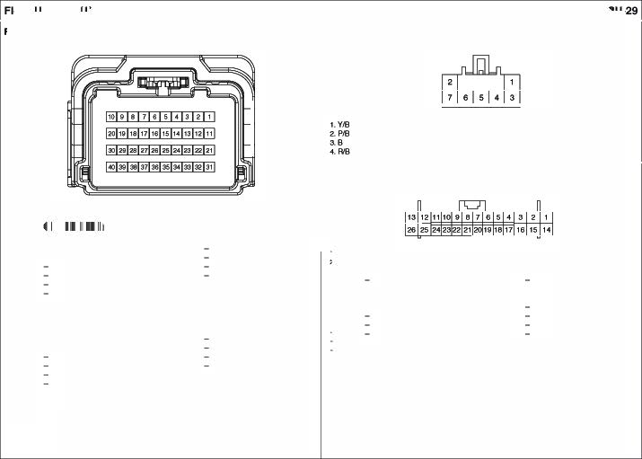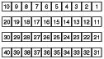17. -
... -
19.-
20.

37. - ""'-
  - L OrMIJSJ8eltBu::kle SIW!ctl(Hig
.... . OrMIJSJ8eltBu::kle SIW!ctl(Low

13,G
SubWo::illw $poakoJ (. 2$.R
Su Wo::illw $poakoJ (. 26.0 s.--""0

-12 Female Wl'llte (NAP_0407_12F_w_070t
    - 1e F-emara/�te CfAZ_025_16F_W)

1.0 RR 6peat;er(•) 7.0 RR-(.)

I. R EM

9.11/0EMC

2.Y
.___ {•) 8.9 RL-0 �-
10.B GJOIJ'ld (GF0

3.R FRT"""'91' Speekel(+) O.l FRTweewSpeaket (-
4.81 RTweettW6peaket (+) 10.W fll""9IMEl Speeb1(-)
  - FR6f)9eb 11.l FR-(.)
12.w flS-•O

Luggogol.Mn
    - 2FEl'l'ltl/Black(A.M _l>l.M2_02f'_8)
"' ""' W�lion Box•TPM 7.6A
� .... l/PJunction Box•UODU..E 1 IQA
5.G C-CAN HiW' 6.-
7. -
a-

fO&. Smart KeyCOn Mo
11. - I�-
13' <>CANLow
14.- IS. -
16.y 4WOl.od<-

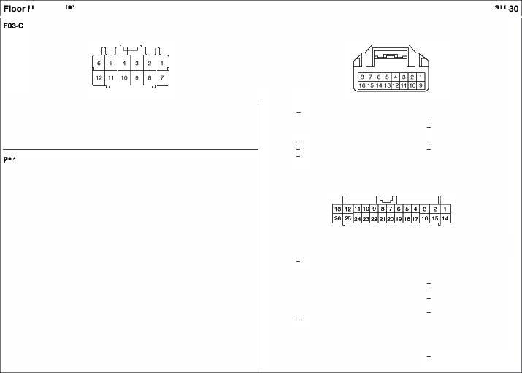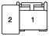•26 l=em /Wllte (!.1*_0407Jef_W_HO)

  - T•I GU.Open &.itch 2.G '1 Jl.lnclion Bo ROOM LP tOA

    - R 11PJonctlonBox•SMART KEY 10A 14.&'8 '1P.llrdonBox•MOOLlES7.sA
�B<IO IMMO. INO. IS.INT
3.9 G10U'ld (GF06) w� lgfillionlock$Mich
4. - All
s.w Tall GQlleHande &.itch GIB 'P' Po9ilion6¥Mch e.. Gfl' L_A.Dl\..L-k 1&.9 <nund(Gf06)
7. p Exaemal 9wzer 17.-
aGIO ALT_L 1&.-
•.wio llPJonctlonBox AUOtO 210A 19.-
- L 8-CANHig 20.W� VILDl\..�k
- A Q.C.o\Nlow 21. -
12. - 22.WIO Dl.,..K...,.
13.0 RF-�RF_OOM) 23.l Start Stop &llOnSiW!ch
{SS9$W2)
24.Q.'8Stop laqt SMectl 2S.WIO EMS COM
26.-

ANr Door SWlc LH
•16 Female Wl'llte(NAP_0407_16F_w_040t •2fEWl'l&le While (AM _O«>M1_0'2 _W)

16 a
1.0 �Al*M•12(Gtound) 9.G .,lefiorAtteMa12 1. - - 2. Y/8 FSCtirWd MocUe

2.L �Al*M•
11(Gtound) 10.R .,lefiorAtteMa,,

3.- - 11. - -
4.- - 12. - - F'I -000<SwtlchRH
£.0 Tai GabAnteMa 13.L Tail Gale Ankttla (Gtow'ld)

... ........ ..........
14.w Bllf11)el'�(Ground)
•2F.-S.I�(AM ...W)

  - 0-"l.D<lJIHT 1£.8 OJ=RJ)FLN4J_GND
....
OJU)"-'1<T 16.W O_Fl._Of_LANT GN

Drrv DoorSwtld'I
    - 2femab/wtite _W)

1. - -
a.. """ FSCtirWd MocUe

F'l1 Smart Anltnna 12
a
•4Female Black(AM J4QS_04F_8_040t

1.- - 2.G'O IPSConltOIMoehle

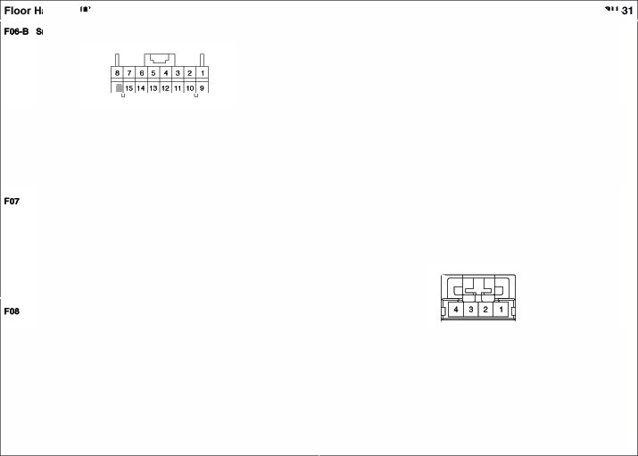Paaeenger Door Swttch
• 2FGn1/WJ'ia (AMP,.040M ,.f16..WJ
1.- - a.. .... FSControl Modi.ff!

1. - - 3. -
�G SmartKeyCoo1re1 Moehle 4.0 St'*1Key Con•Ol"6Cd.lle
(InteriorAlllef'lnen ONO

•5 Ff!IMl&/Otay (KET_OflOl_�F_Olt_2 •2F.-S. Black ..02FA

'·- - ••• EM Box• FIPUMP Relay t.Ol8 EMSBox·SENSOR1 10A 2.01 PCM(CCVC...U�I

2.0 ��·Fuel6ende 5.9 <lnd

��·Fuel6ende

F1 DrlYwSeelWanner
  - •female/Wtit& (KET_090IL04F_W)
(GF<lO)

F'1 FuelTankPrMtu Sln:s

.3Female Black(AM _oeo_oa _B_WP)

I.W

3.9 °"nd

(GFol

1.l

PCJ4 (FTPSQound)

3- PCM (FTPSSignal

- ·-(Low) •.I> Hl.- -Po-Oullol
·2Female
F1 Passenger SeetWanner
  - •femab/wtite (KET_090IL04F_W)

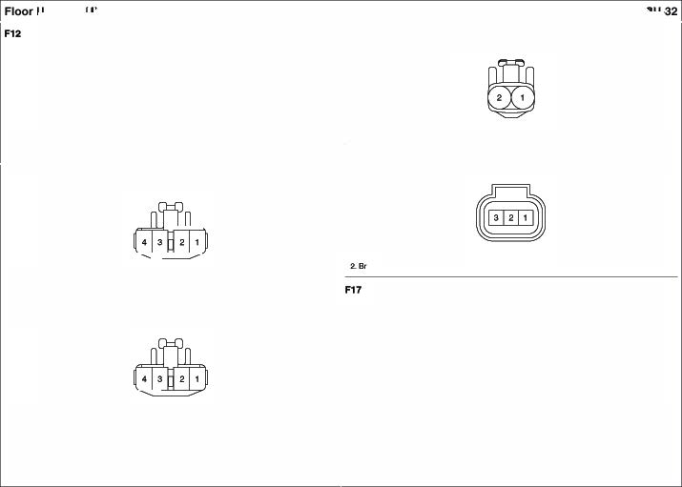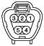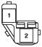

'·w Swiktl(Hig 3.8 01ound(GFQ5
Swiktl(Lo •.I> Hl.-
1.l llP..k.nCllon8ox• 2.8 °'°""'CGl'OOI POwEAOtnlET22SA

Yaw Rate Sln:so 30
·8 Female IBlar:*(AMP_MOSWP_06 �-1 ) • 2M#e/WlieEI (l(ET_«K>102M
W_L._1)

••• ESC MCIC!Ue(CANlo. 4.US ESCLbUe(GrCU'ld) 1.l ESCMoch.'9 (SIG) 2.R ESC ,_,,.CVCCI

2.Y ESC MCIC!Ue(CANKgrl 6. - -
  - ESC MCIC!Ue(Po¥fel" 8.- -
F31 -- Senoor RH

_,Comblnallon Lamp(O<l LH •
    - 6female/Slack (KET _B)
2Male/wtWe9 (l(ET_«K>102M
W_L._1)

'·y ESCMoch.'9 (SIG) 2.8 ESC ,_,,.CVCCI

I.W BCM(T..rn&HtUardLamp) 4.0 WP.An:t1on Box· IPS7 F32 Hand P11rtdng Bnb Swttcn(MIT)
2.- - - -
5.

3.<>8 KMFteiey Box(OS Aelay>
O•••""' (OF<Xl)

1 femaleI Blaic:t(MIP_Pl 01F_8

-rComblnallon Lamp(O<l RH
    - 6female/Slack (KET _B)

- G1IO IPS Cocri'ol Mlolt.lle•PaMngera Wk:tl

F33 Foot Parldng Br- SwMch (A/T
  - 1 Male/Ellck(KET_250_01M_8t

I.p BCM(r..rn&HtUardLamp) •.Ero WP.Ancllon Box· IPS2 2.- - 5. - -

3.<>8 KMFteley Box(DS Ael&j) ••• a'''""' 10"'8)

- 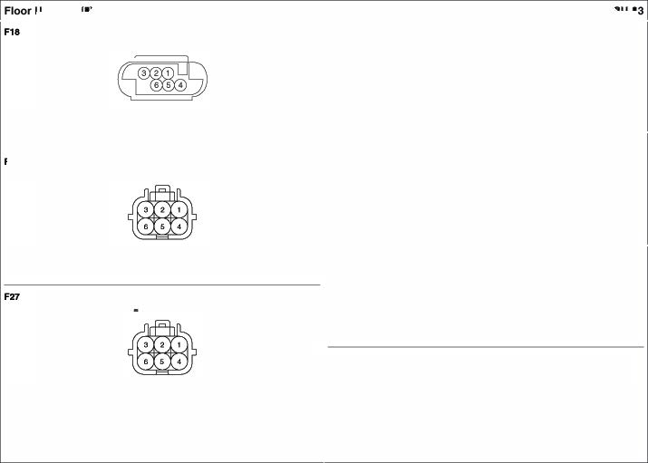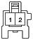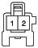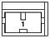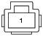G110 IPS Cor#OI MrXlle

•Palil*lg81ake S�'="

Roof Anlenna
·"Ferntlkl/wt'ite (KET_090IL04f_W'J • I F.-S.181ack(AMP.,.PU.1

I.y Audio�

I.A AJ.IP (·) 3.0 AMP(- F43 llrfn Sid Air Bag
  - Alll' (•) 4.0 AM ·2Female/Yelow(YAZ_040WP_02 _Y_GH
ATM ShiftLev. ILL
    - 2ferntlkl/wt'ite (KUM_COR_02 _W)

I.GIB SASContdMoch*' (N'1)
2. """ SRSCoonlro Module(Low

F44 Pa....,gwSldo Air Beg
'·A.<) u. (•) 2.LIO • 2Female Y£«a.(YAl_04'1N _02 _Y_GH
Smart Koy Anlenna #3
- 4F../Sllck

1.8'f8SASContdMoch*' (N'1)
2."" SRSCoonlro Module(Low

F4S - Side Impact -- LH
'·- - 3.- - •2F.- 0.111 Gn11y(FCl,.PAEWP_<Xl .,.DG1..B)
2.0 Smart KeyConuol Module 4.l SmellKoyWord"""'
(Tail Ge.19 Anteme Signal) (T Ge» �maGl'Ol.nd)

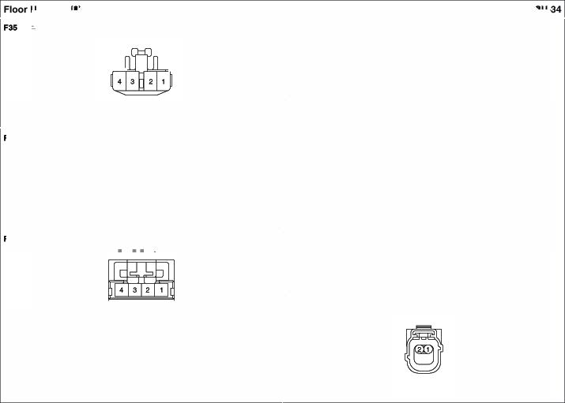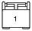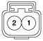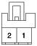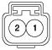1.l SAScar.Cl Moch• (lf(l)
2.0 SASControl"600.Jle(Low

Rer
Sfd Imped SenlOf RH
Se Dr Sea Bel Buc Swttm

    - 2F""'* D-'tGray (FQ.PAEW ..W'.J)Gr,..B)
•&F.-S. ..owCJST ..Y)

1.0

SASConlJOI Module 2. 0

'· p
�-
l�l�l!lsl41
SA Cont Moch.'9 llO'fr) s. 0
- &l

3. -
4.

- 7. -
&. -

Eloctrcnle Uognelle VolwCluld
·2 F�/OA"ay (KUMjl.IWP_oe _Gr)

S7 Dr Seal Bel Preteneloner
•2F.-S.I81ackCJ$T

'·.

FSS Paaeenger Se Be• BuddeSwitch
• 8 06F..Y).

PJB SASCcri'dMoch*' (N{lfl 2. GI' SRS Control Module(Lo S8 Paeaenger SMt Be -­
,2F.-S.I81ackCJ$T

  - PIS SRSConltolModul4t{\.ow) S. - -
SRSCoc*dt.b::k119(Migh)
2. .. .. 6. LIO

3.-
..
1. -
•. -

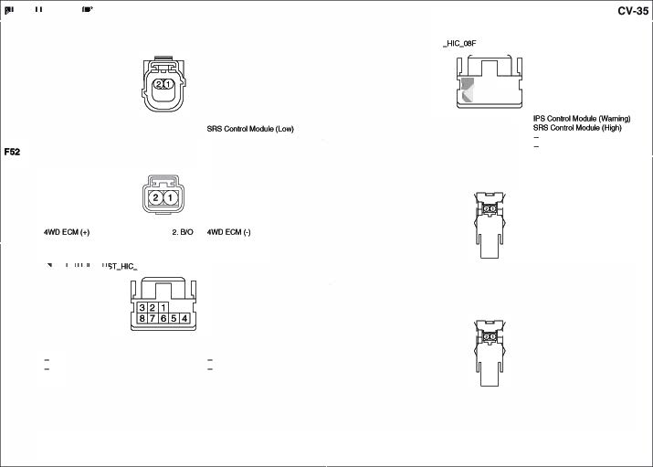

LIO SASCcri'dMoch*' (N{lfl 2. Y/8 SRS Control Module(Lo

    - 2FEl'l'ltl/Black l_AKll_02F_BJ)
F8 a.a T�lon s.naor

•3FEWl'l&le K' (EPC_ES708_03F)

  - LIS POS
(Power

••• SRS Coonlfl:>I MoO.ile (Lo

FllO Drlv CUrt Air Beg

2FEl'l'ltl/Black l_AKll_02F_BJ)

2.A

SRSCol*d Lbt.ile(�h)

2-8 G1�0f'09)

ZD Diode
    - 2 fern;je 81ack(KET_090_02 _B_OIOOE)

  - 2. WJB TaiGa.bOpenSwilc

FS1 Pa Ocupont D9lecllon Sensor
·6femab/81ack(JLUB,AG_O§J)

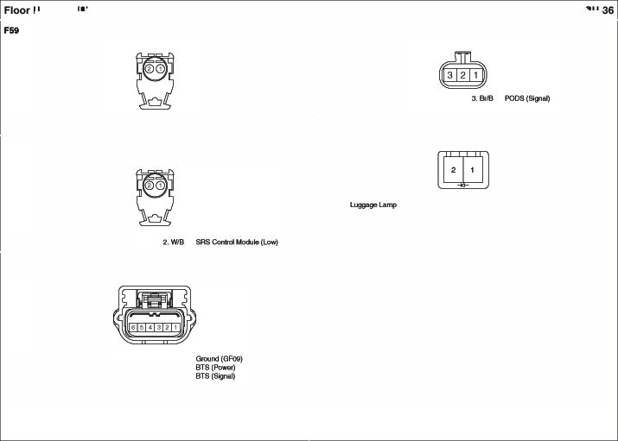'·y
2.0
3.0
W.Ainc*onBox•NBAG 1M C.CANHlgh
C.CANLow
4.9 s.UB
o.e.e

D07 Drtve Power Outl Mln'or
    - 1FEl'l'ltl/ll& Black(FCLAC1'RWP_o7f A ·8fEW1'181e/81ack MLX._Ot0_08 _B_N

1.0 | tCMRetay Box | 5.9 | -nd(GFo | I.GIB | OubideMiflU'�•Lefll(VL) | .. - | -
2.0 | (TwoTum U!Woc* Relay)  w.Ainc*onBox(DOOi'Loe* Relay) | •.<> | IPSConltOIMoehle | �·  �GllB | OubicleMiflU'�•UptOo..,_,  OubideMiflU'�•Lefll(HI.). | ··-  7.. | -  GJOIJ'ld (GF0
"'"  4.P | IPS Conrol_.,(!("' lod<) IPS CoMolMcxUE1 (Key lkllock) | 7. - | - BC'4·Turnl.amp�Fl. |  |  |  | l1P.bdonSox·HT MIRR 7.6A
Po-Ou lllrror SwMch
Drtv Smart KeyOut Hondlo • 12 Rwnar /'r\tllte CAMP_0407_12f_w_o7f/J

... Male/E!lac* (KET_SWP_04M_8)

'· - - 7.- -
1.81 Smart KeyControl 3,w Smaltt<.,,.Qnd MocUrt 2. - - aoe Oul&lde lmCf SMectl (Vl)

(0..R..DfVNll (O.J'U)R._GNO) 3. - ··- Oul&lde Mir«
2.Gr.V Smart KeyControl 4.9 Gsouncl (GFO 4.- - 10. p
SMectl (1-1.

Drtv Press. SkteImpact Senso

�9 G10U'ld (GF01 11.01 Oul&lde lmCf SMectl (1-1\)
e.G llPJonctlonBox AUOtO 210A 12.G

·2 fernekl/8rown FCLPAEWP_oe _Br_C) 009 Drlvo Poww Windo llotwfN/O 8aloly

•2 Female G1ay(FCLSENSOIL02F_GR)

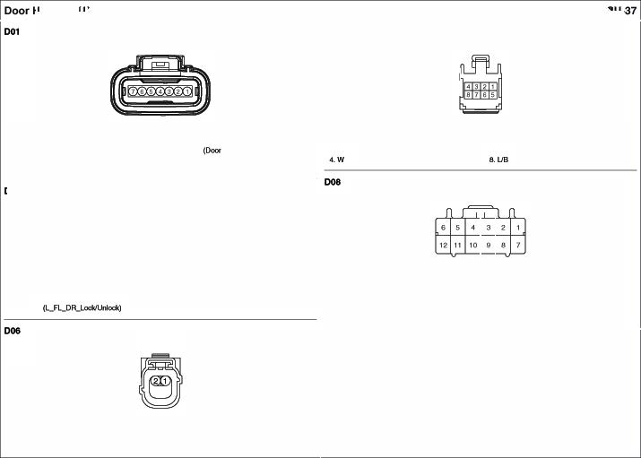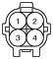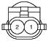
1.8 SASc..... ModU -) 2.W SASc.or.rd UcKlle

(Low)

'· p OrivefWindow Switch 2.W °"'9 WindowSIW!ctl

• 16Hl 1T11'4tl �itlt ('KET..OOlll.1., 6F...W)
013 llrfvo Do SpMl<w
•2 Female

I.Gr P....,Wwtdt:twSwiktl
2.G P...-.gerWwtdt:twSwiktl
3.A 1.L (•)
..
8. WitlSIMty
G S.r.ty PoWM Wndawt..lcd.A9 (Oown)
WJOSIMty
1.8<

Drlv. TWM«er Speler
2. w

5.Gt.fl IPS ConniMc::dM(Doorl.H:d;}
6..W S•ty�Wndow�(�ID
1.WilhSafetf
L S•ty�Wndo

W/OSafetf
W OtiYer Power WndawMotor
P om. Powot-W1nc1ow Mok>f
9. A �pJl.lnclion Bo PfWO RH 2$.A

12.8 Gsouncl (GFO
t3.IJ8 1P$Conlrol Mochff(Door Loc
•2Female wtjje(KUM_CDFL02 _W)

t6..0 �pJl.lnclion Box• PfWO LH 2S

012 Drlv SafofyPo-Window -.1o (Wllh Sa!O!y)
- 6female/Slack(FCU,.!NIWP

1.W

02 Pa..o• Door LockMtullor

2.8<

Sc:>eaker(+)

•7Female _8)

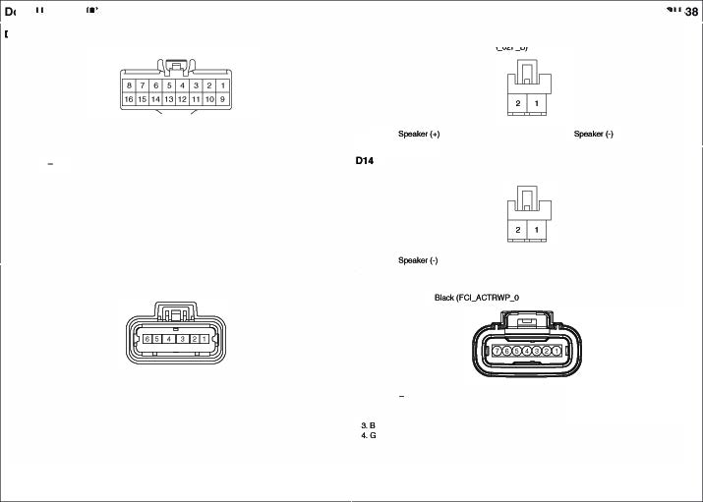1.0
2.
3.
°'""' - (Doon)
Driver Wi'ldowSwitch(Up)
�(GFO
•. v

5.W
8.0
�P�!Ion Box•
SAFETYPOW WffXJW 20A
OIMw WindowSY.iect1 (Auto)

8CM

1. -
�w IPS Cocri'ol Mlolt.lle
(Door Loc:kl\J...°'*)
GrOU'l<I (GF06)
IPS Cocri'ol Mlolt.lle(�U\I

.... 8.0
7.l

FSC:C...d MocUe (KeyI."*) l1P..udonSox(Dool' W*ANy) l1P.bdonSox
(Dool'lkb: Aday)

Passenger Smart Ke Outside Handle 029
- 4Male/Blaclc (KET_SWP_04MJJ} •2F.-S. Gu1y(FCt,.S NSOA.�
•

I.W Sma KeyCon!rol Module 3.8 SmartKeyCol*d Molt.A!
.... 2. P Wrdow�tch

(O_FIUl_lUNT GNO) Pauenger P-Wlndo SWllch
2. WJll Sma KeyCon!rol Module ••• Glound (GRl6)

IL."-"
• 10 Fem v.tiite l'KET..090ll,..,,.20F W)

PaN•nger Pressure stde Impact Sensor
·2 fernekl/8rown(FCLPAEWP_oe _Br_C)

t.R SRSC..vot,._(Hgl>) 2.L SRSCo<wd-. (Low
'· ""'  z- | ILL.(•)  - | .,"'  1.e | WndowMl
3. 6118  •."9 | IPS Col'*ol J.b::klllo(OocwUnbc IPS C.O..ol Mo<kile(Doorloc:t:) | 8.  9.L | .,p.MdonBox•PIWOW RH 2SA
 |  | 10.8'

Paaeenger Power OUtekte UlrTor Pa..gw Door Sp-
&fernElkl/81ack lX «>_06 F_B_A> .2 fEWl'l&le 81ack (KUM_C0�02F_8)
•

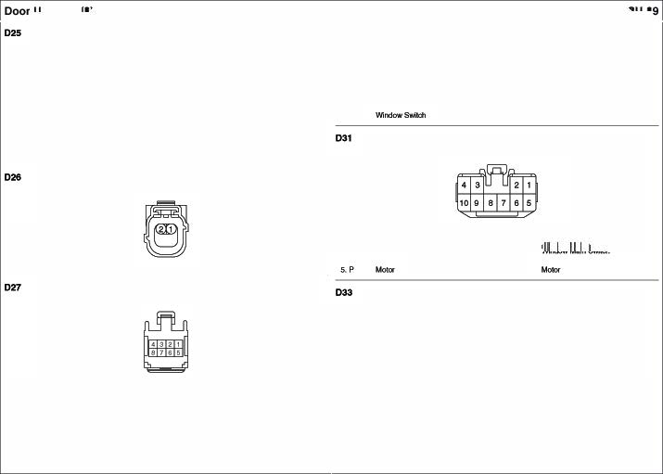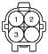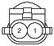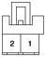
1.0 "'- Mino< -.•,,. (VA) 5. - -
2.P "'- Mino< - · U- ·· - -
"'"' "'- Mino< -.•,,. (HR) 7.9 0..Und(GF<l6)
4.P BCM•T-..nLa11tt0ulp0t RR 6.U8 ., �lion Box· HT MIRR 7.sA
t. R $poab 2.L -""

OSO R&ar PowerWindowSwth LH
•&F.-S./�(KET ..W)

1

'·L $pukor •••

1.0

., .MdonBox•PIWOWLH2SA

�·
Window Mai SIWlctl

RNr Doo Loc Actuato LH
1FEl'l'ltl/ll& Black(FCLAC1'RWP_o7f'A
3.8
...
�-
LL(•)

•

053 - 0-Spoe
•2Female Black(KUM_COFL02FJJ}

I.L llP.llncfiBox
  - llP.llncfiBox
3.-

{DOOi UnlockRelay) •••
{DOOiloclc Rl!lay) •. v

Glound (GF(ICl)
FSControl Modi.ff!
(Doorl.ockl\.k)H:lc:

4.- "-
'·y
2.8

ReiarPowwWindow MotorLH
    - 2 F""""i<J<ay (FQ_sa<soR_aiF_GR)
06 - 0- Loc Attuator RH
- 7Female 81ack(FCl_ACTRW _o7f_8)

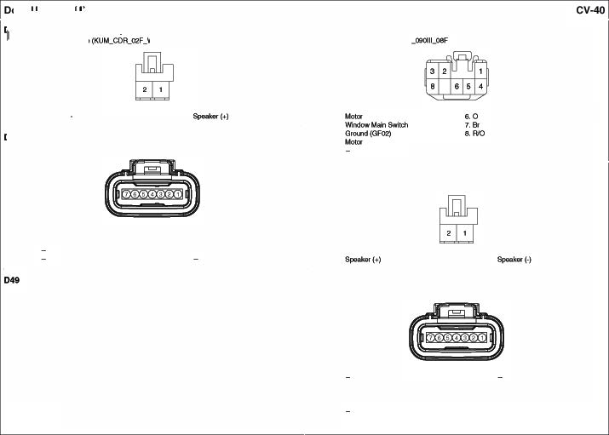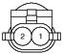
'·L Witmw Sricfl 2.G

WilcbwSwilc

'· -
�y

3.8
<.-

IPS C.O..ol Mo<kil& (000<t.ockl•lJ odO G1W'ld (GF06)

s. -
6.
7. L

., .MdonBox(DoorLodi: Relay)
.,p.MdonBox (Dool"""''"")"'

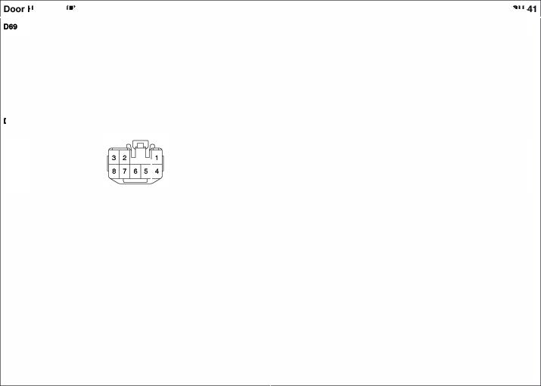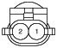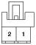RNr Poww Wind Motor RH
•2 '""'"" °'" (f'Q_SENSOll_02F_GA)

'·p Window &Mectl 2.9' Wi'ldowSwitch

RNrPowwWind Swttch RH
•8FEl'l'ltl/ll& Wti1& (KET_090I L06F_W)

I.81 ..... ••• WP.Mclion Box· PIWD RH 2&.A
2.L Window MainSwilc 7.0 Wbt::lwua SMdl
3.8 GtOW'ld(GF08) 8.AIO U.(..)
4.p .....
6.- -

073 RNrDoorSpul<o RH
·2 fernElkl/81ack(KUM_COR_02 _9)

1.G $poakoJ(..) 2.0 -(-)

ROS Room �
•10 Female IBia!:*(SUM_005 10F'_9) •.3F.-S. �(AM ..W..HOR)

- IS RearView Ceme (Vid9oONO. (·)) 6.G �p�!Ion Box·ROOM LP10A I, R llPJonctlonBox• FK>OMLP 1OA :>8 <nund(GM<lO)

2.- - (Homelttl
:> RearView Ceme (Vid9o Power(+)) "- -
2.8'18 ...........

4.MI RearView Ceme (Vid9oVGNO,) 6.8 -nd(GM02) - Drt Vanhy Lim
  - RearView Ceme (Vid9o In) O.L �P�!Ion Box•

Back·�laqtfletQy
10.G1K) �p�!Ion Box·MOOll. 2 10A
    - 2 Female IBiid(AMP

Map Lamp
- 4Femaie/Wtit& (AM _OEIOllL_04 F_\V)

  - WJl#IO'lion Box AOJ4

LP 10A ••• GtOW'ld(GM02

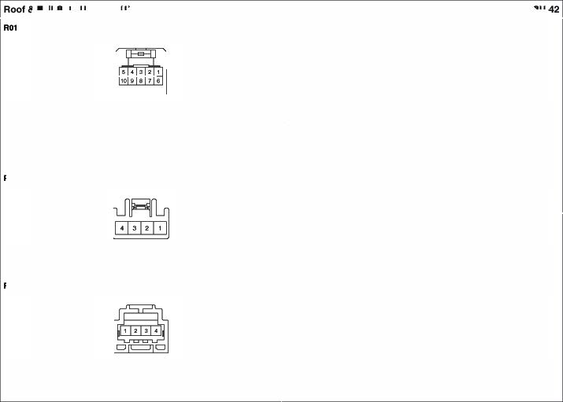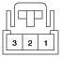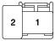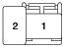
A0 Pauengw Var1ly Lamp
    - 2Female I Blade(AMP
••• | �(GMCQ) | •. 9'll | ...........,
2.0 | llP.Aildion6ox ROClALP IOA | <.El< | 9CM(Room l.ampConni)

ll
•10�/81ack (MI _MOS_<>I I, G VPJ� Bax• ROOM L.P IOA ••• G-Ol.l'ld(GM02}

'·R | Auclo | 3.- | -
2.8 | Au<lo (·) | <. - | -

-
•4 Fet1'161a /Wl'il& (AMP_070_04F_\V •9MalaIWtil&(KUM_COA_OeM )

•.8'18 CloHITil DownSMkfl 3.8 GIOl#WJ (GM02) I, R R9al"Vi Camer (CVBS} e.e <nund(GAo
Till UpSMkfl 4,W 2.1' R9al"Vi Camer (VONO "e <nund(GAo
7)
3.G/8Ill' JunctionSoxOPS &. YIB TalGate HardeS"'9ctl
7
4, R9al"Vi Camer (8+) 0.0 l1 .llrdonBox•IP
�VIS R9al"Vi Camer (GH)
- &ferntlkl/wt'ite (AMP_OQOllLoe _W)

Rl RMI' Combinatio Lamp IC) LH
•4F_...S./�CKET ..W)

1.e 5,W °""'
2. | l'P.Alnc*onBox•SOOROFO ISA | 6.L | TltUp
3.0  4.811'3 | l'P.Ainc*on8ox·MOOULE4 IOA  CloeelJlltOO'M'I | "-  8.9' | -  V""*'-Sio""

1.8 | GrOU'IO{GRO | 3.G | l1 .bdonSox•FS7
z- | - | ••• | l1 .bdonSox•  Back·UplM'pRela

HlglHllounWd 91<>1> Lll p
- 2Mal /'Mllte(KUM_OOR_02M

R14 R- Comblno1ton �(IN) RH
•-4Female IVttille (KET_6'l _W)

l,G/8
2.9 0..Und(GAol

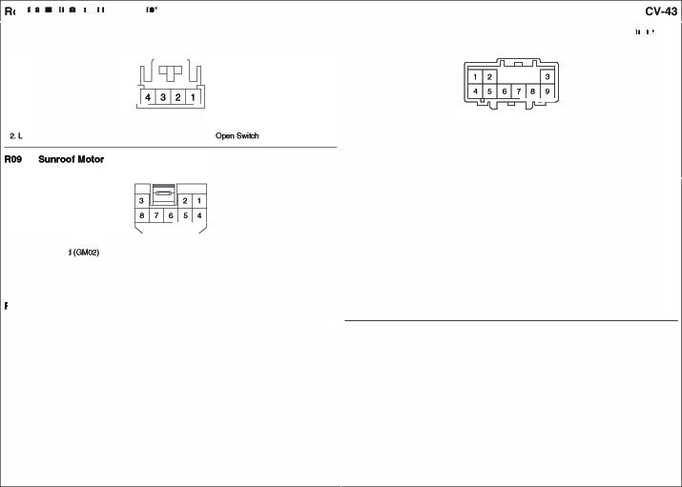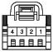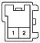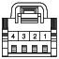

I, 9 | Ground(ORc1 | 3.Y | W.Ainc*on Box•IPS2
2. - | - | 4,R | w.Ainc*on Box•  Back-Uplam Relay

•I FGl/lnllh 811ck(AM _Pl.U2.0
1F,.e)

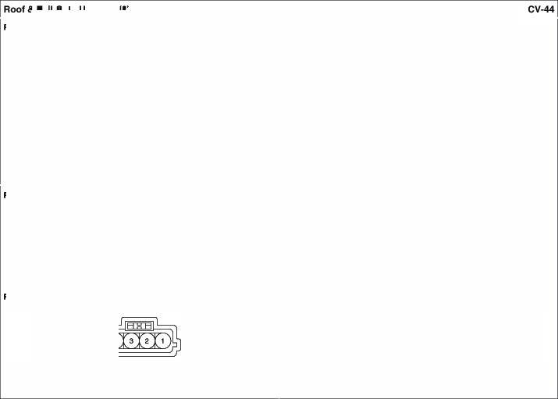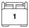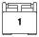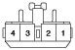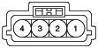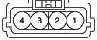

  - Grcund (GF<X3/0Ao

Rl - Delogll'f(+)
    - 1 F�/Black(AM _pl_M2_

  - EJ Fuse&Ada Box• RRHTO Ada RNrWiper Motor
    - "FernElkl/Wl'i19 (KET_090t lL04f_W)

T•llGatoLaich
1.8 | GtOW'ld(GR0 | .. .. | ICMRl!layBox• AMI-�Ada
2.W | tCMRela Box• Rl!9I'Wiper RNy 4.L |  | WP.Mclion Box· WIPERRA16A

- "FernElkl /Black(KUfo1_NOWP_O<I _8)

1.8 | �(GR0 | 3. L | �PJl.o:lion Bo TM Gate Rela
2.w | IPS Connl�, �l.Jlq> | •.B | Gsouncl (GFIO

•2 FEl'l'ltl/Black(A.M _£JW _02f'A

1.e Smart KeyControl 2.w Smaltt<.,,.Qnd MocUrt

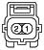(a.IT'I* ,,..,.
$9\1 �Anlenl\I Grciu

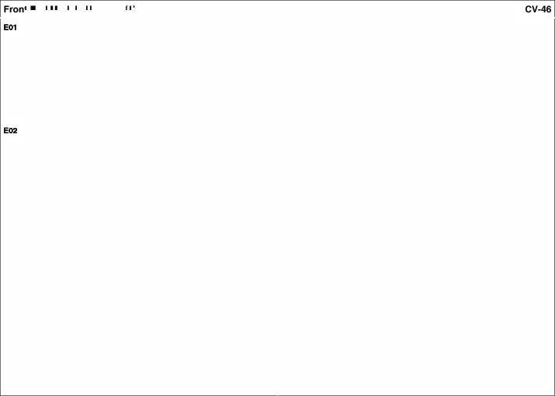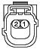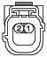Drtv Ff'OIW mpact sensor
·2 FEl'l'ltl/ll& 08ftG1a J>Qr-8)

- Br SASConlJOI Module�) 2.W SASc.or.rd McKllle(Low) P9...._ Fn>nl lmpoct Senso<
  - 2Female/DlrkGra J)Gl'_B)

'·L SAS "°"'°' ,._(14!1>) 2.0 SRSCoc*dt.b::k119(Lo

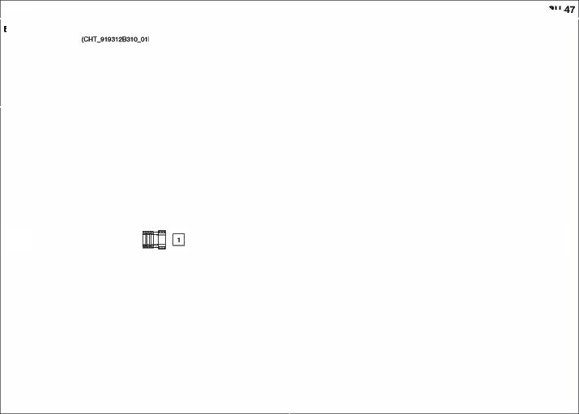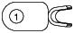Batte Harness (1)

Start Mo!Ot'
• 1 F""'* NIA

  - 8ater Power

E12 Star!Solenold
    - 1 F�/OA"a (KET_.sex_ _G1)

�
I.A E.11=1FUM &Rela Sox S1art Aiolay

E13 An.mater
• 1 F�/N/A (TAE_919ENX3K 00_01F)

1.e Baaery&8&ttety FU9 Booe:· AL 1SOA

Drtv SN Ma Swttch | 804 | Dr!Yo Holgh llo!O<
- 20FemaleI llVA.(/IM _070_20F) |  | -4 FEm81e K' (AMP..JP,,1 _4F)  •

3

I.81 ()-Mirl.1#'111»1$1.c>port&.itch (R)
OtiYer Flecl ..ng Switch (FR) I.UY

a- -

2.e °"""" (GFOI OtiYerFlecli,_ng Un SMkt (FR) �""' S&6'"8,.W SW::fl (Oo...n) .. - - 3."" l>W--(FR) 13. G OtiYerFlecl ..ng Switch (Fl\)
4.Ml l>W - S05 Drlv. Slkl Motor
R llP.Alldion 6ool•

C>W
•<..eGIR °"""" (GFOI 15.
......s.m. (lloon) PJSEAT(ORV)20.A
•4Female WA(KET_090-2_.u:)

7.VV ()-Mir HoighlSwilc (Up)
OtiYerl.utrt>w �Swiktl (FR)

ae °"""" (GFOI ''· 8 G'ol.nd(GFO
··- - -
10.v C>W-•ml-(RR) 19. - -
,.._ -
I.UR | SeMMaN.181 SMk:h (FA) | 3. | -
�- | - | •.Ml | Sea Man | Switch (A

Drl- Aocllnlng Umtt SWltc
·3Femaleltt'A(KET_�03F)

3 2 1

DriverSe Wanner(Wti Power Seet)
• 4Mele �A (KET.J)9()-2_04M)

  - Se Mani.Ii Switch('FIR) ae Ground (GFo
1.BIW
�G• Se Mani.Ii Switch(FR>

Drlvw Aeclhlng Mo1or

INO.(GND) 3.y Seal&Mtch

Sea &Mich

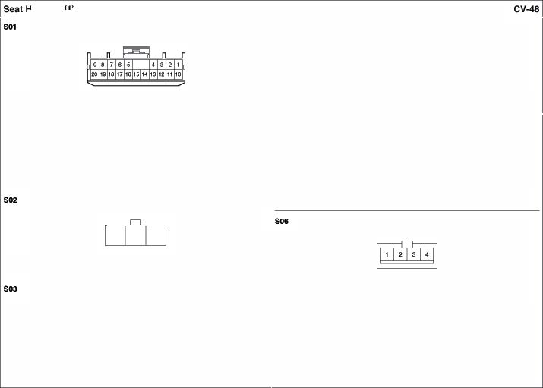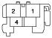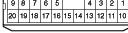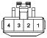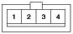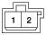
    - 2Male (KET OOOH_02M

  - Sea Man Switch(A 2. Y/Ft Setlll MarllalSMkt1 (FR)
�· Gr'OU'ld(GF01) 4.R

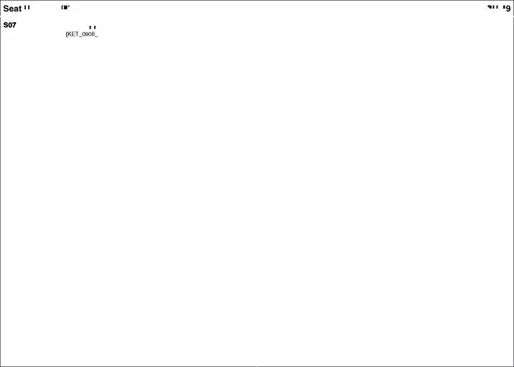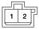• 2M•lt¥ 00M

.... Sea Manua SWilc (R 2.UW Seel '4arl.lal SMdl (FR)

    - 1 Male/E!lac* (KUM_NMWM_Bt
    - 1 F9n#e/Bl1ck(KUM_NMWP_01 _8)

I.A I. A SW. Scil!U:I

CFll Fk>or To COn1rol Hlml Corw.ectk>
•22Meil& While(KET _�IL22M_W) ·22Female While(KET_�11-2..8)

I.- - 12.lJS
2.0 ICM- Box(De Relay)
3.W� -LodoS-(Mlf) 13.0

LO'*)
ESC- |  | I. - | - |  | 12."9 | YawRate Sen9of(0.-ound)
Cffl'N f\1186en&of  ESC- | Gtound | 2.0/8 | ...,,...... Soop.._.  Sq.Lam l.Hlfl |  | 13.0  14.8 | YawRate Sen9of{Powef) YawRate Sen9of(CAN

4.Y ESC,._ Cffl'N f\1186en&of Power 3.WIS INT·SmartKoy C..V01 ,._ 1S.Gl8 Nr· BC Srnert1<$1Cof*Ot
(Yaw RateSeA9CW• CNf�) 14.8 ESC- -LodoS� Mod'*>
5.8 ESC ,._(AA\/CCI Cffl'N f\1186en&of• CAAi (Low)) 4.Y Yf!Ni Ra186en&of(CAN High) 16.Wi .,P.MdonBox TPM 7.SA

6.Y ESC ,._(AASIG) 15.0/8 ATM Shfft leot 5.8 R9al"Wtw:N:ll Sen90f RM(VC)
17.01 �Clo6e YM (eo..o(l

7.A ESC ,._(ALVCC) ('I'Po<llloo s.ib:h) e.Y R9al"Wtw:N:ll Sen90f RM(SIG) 18.0/8 �Clo6e YM (Power)
&l ESC ,._(ALSIO) 18.W/S ATM Shfft leot 7. A R9al"Wtw:N:ll Sen90flH (VCC) 19. p 9rnanKey Coon•olMo<klle-
•.Ol8 s� LMl>SM.t:::l'I (ShitLoc SolenokQ 6. AEIElfWheel SeMOIUt (SIG) !"'°"'""-

10.- - 17.Gr
9.0/8Smar KeyCoo1re1 Moehle(Stop} 20.G nPS (Slgnel

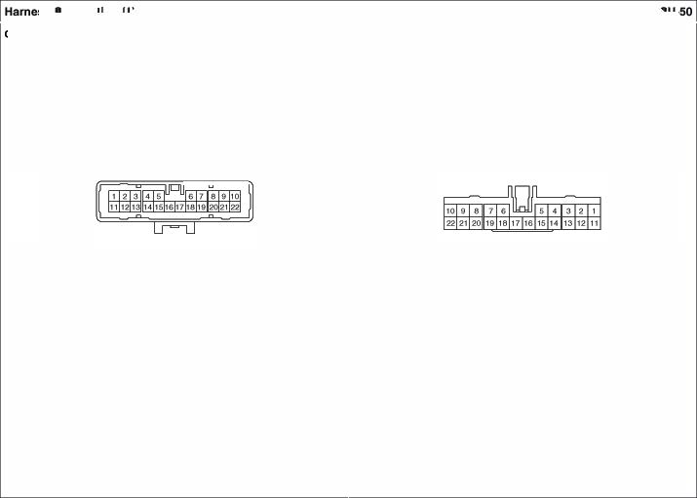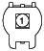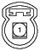11.- - 18.0/8 EM Box• SENSO I 10A 10. - - 21.8' nPS (GIOW'ld',l
19. p -Buz.lo< 11.- - 22.l nPS -
20.G PCM
21.8t PCM (nPS<l<"""'l
22.l PCM (SEWIOISuwfy

•2 FEl'l'ltl/Black(KUM_N!.IWP_02FJ3) •2 "'8leIBiid(Kl.l.l_t&IWP_02M_B)

�
'·81 OtiYer Fronl lml*Cf S.l'GOf�) 2.w om. Hant lq)frd Sor1ll\Of(Lo 1,13< SAS• 0"'9 FIS(High) 2.w SRS•I>""F1S(I.ow)

EC21 Front End UOduf Hame88To Controt Connection
• 2Male/er.d; (Kl.1.1.,.,.Nt.fWP 0'2M..8> • 2 Him ISlk

�

(KUM.,.Nt.f,.WP OQ .Jl)

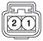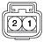
1.L | PISSCliigl!I FfOMl"l*' &msol' | 2.0 | Pas | Front �Serlsor | I.l | SAS•Passer19&' FIS(High) | 2.0 | SRS• Panenges FIS (low)
 | (H;gh |  | (\ow)

FD11 Fk>o To Drfvll' Door Ha COnn.ctk>n
•45�/81ack (K£TJiYBAI0_<15M_8

1.0 | P88SIEr'lQ8'Powe VN'mw S� | 16.l | Fleer Powe Wll'ICkM'S'IAk:h AH | 31 | BCY | 41. -
2.0 | l/P.)JrdonBox P/W LH2SA | 17.y | ll ..U.Cllon Box• |  | (Tum& Hazar LampOIApul:Al. | •2.-
3.- |  |  | SAFET POWER WffX1W 20A | 32.B | G10U'ld (OF01 | 43 RearPowetWondow
••• | P88SIEr'lQ8'Powe Out9kleMirTOI | 1&0 | P$seenget Powe Out3ideMrrct | .... | IPS CorWOl"6rXllle | 44.0 RearPowetWondow�AH
•.o  ... | llP.)JrdonBox•AUDIO2 IQA  SAS· OIM!tSIS�) | 19.0118 | IPSConlJOI Modi.le  (Dool IJnlrX:j( s.ilCh | 34.R | (DrlYef DoOfKIJI unlockSe1W  IPS CorWOl"6rXllle | 45.WIOA.M  w """°. Fl(-)
 | SAS· OIM!tSIS(LOW | 20.LAI | IPSConlJOIModi.le |  | (D<"" Ooo<Ke>flode Sl{J'Ol | _,.,,,.

&­
7.W
..-

10.-
11. Br

12. w
13. e 1<.LAI IS.

Wllh AMP·AMP(Fl(•)) Wllh AMP ·NAP (R.(-))
QOW'ld(0Fo llP.)Jf'donBox•HTO MIRA7.5A. llP.)JrdonBox•P/W AH2S

21.G

22.Gr
23.0118

2-4.R
25 -
2&-
27.-
28.W/O
(Ooo< l.Oci<._. K:MAellrf8ox (Two•...,""""Amy IPSConlJOI Modi.le
(°"""'°"' """""'°"'Sl{J'Ol
_,Key""'""' """" iL-F
ll .Ancllon Box IPS 3 (l.l
36. 0 "'·"' '7.-
:l6

».I>

<0.0
llPJunction8ox(Door Loc Relay) Paeee�Powe Outside l.llnor

SmartKeyCoo1re1 Moehle (OJL..l>ll_AN ONll) SmartKeyCoo1re1 Moehle (OJL..l>ll.AN
BCY(Sele
w --Fl(-)

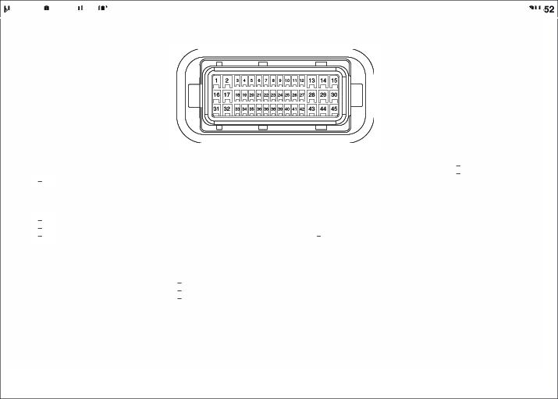8t Atl<lo R.(+)
Wllh
8t AMP ·R.(•)
29 GI Pas �Window&Mich 30.8' Roal' MVOWSMdl LH

1.0 Power WhdowMai S�
(F'$seef19EWWindowSYM:)::h
2.0 | Wllh S8'etf• WlndoW Sd:tl (Fl 8+ | '"'0 | Sele\' PowerWinOowMcdA& (9-.  Powe Outside l.lrro SwllCh (VA) | 32.8 | (Tumlaflll)  G•OU'ld | 43 | ---SMICh(Fl.)
 | W/OSMetf• WlndoWSd:tl | 19.011 | Powe W9'IOO'wMainS'IAk:h |  | Powe Wll'ICkM'Main Swltcl\. | 44.0 | ---SMICh(Rll)

17.y
Powe W9'IOO'wMainS'IAk:h (AA)
31 OrtwJrPower"Oul8kla � 41. -
42.-

(Orh<Ew FLS.- (Ooo<.-('-"I""Q
3.- 20.llB Powe W9'IOO'wMainS'IAk:h
4.P Power Out3id&Mrrot SMk:h
(Ooo< .....(locl<)>
21.G OrMw Dool LodeActu810f (AcU:ltor
•.o | (UP'"°"")  P<M'a'�Mrrot SMk:h (ACC) | 22.Gr | Orh<er Dool LodeAClue.IOf | 34.R | (Key"""'kl  OrtwJrOoot Lode Att.lator
... | "'"" Side_...._ ("ll!) |  | (Dooll.Ockftlnlock) |  | (Keylcdq

Saletf P0WEWWIOOOWModule. ....w .....,_ _(-)
PowerOl.feide Mlttor WIOAJ.IP ·
... . OrtwJrOoot Lode Att.lator .....,--·-<->

7.W DrlY Side�Sen9or (loW) 23 011 OrMwSmartKeyOulSld&Handle
8.- ilOCI< -II)
·- 24 Powe W9'IOO'wMainS'IAk:h (llL...)
·
1 0.- 25 -
- Br WllhAM 2&-
36. 0 OrtwJr Ooot Lode Att.lator(AcllJakW) "'·"' Powe OlleideMlffOfS�(HA) '7.-
:l6.W OrtwJrStMl1KeyOIAskle Handle

(Ar<eMa-1

•DrlY Door TweewSj)ElebW (+) 27 -
- w WllhAM "" OrMw Ooot Spea (+).
•DrlY Door TweewSj)ElebW (- W.0
- e "'°""'· OrMw Dool TweetetSc:>eaJcer (+)
».I>

<0.0
OrtwJrStMl1KeyOIAskle Handle (Al'*Wla+) Saletf P0WEWWIOOOWModule(COM

DrlY OocwldAl:tJalo.t
DrlY SnwtKeyOl8cle t\lindl&
29 Powe W9'IOO'wMainSrM:h

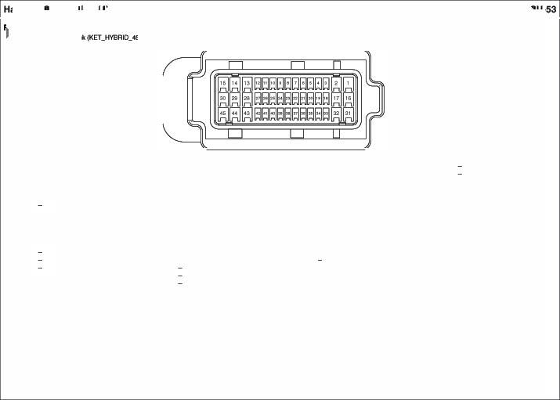DrlY Powe OutsideMfrrot 30 (,,_ ....,I(I) Fl
Powe W9'IOO'wMainS'IAk:h
1 4."" Drlw!r Power OVlside UifOI
(Ddogg«I
16.R PCJWel'Wrdow Main�
•Wrdow &Mtch
(Pass.engel'8+ AR S.

FD2 Fk>or To PUMngl Door H.,,.... COnntctlo
•45�/81ack (K£TJiYBAI0_<15M_8)

I.. 16..
19.•
2••
3.0 llP.)Jrdo Box{DoollO(:j( Ael&j) 20. IPSConlJOI Modi.le
... <"- Ooo< Key Sl11>81j
••• 21.G IPSConlJOI Modi.le
... <"- 0oo< Key"'10cl<Slgna
7..
... 23 SnwtKeyColWol MolU&

••• (O_F1Ul_l\.»IT GNO)
2•.Wi9 _,Key""'""'""""
11•• iL-F
.
- 25 IPSConlJOI Modi.le
- A llP.)Jrdo Box•P/WrYW AH2S <"- Ooo< l.Oc>llMlod<Signal l<.G< Power Whdow Mai S� 2"·
(F'$seef19EWWindows.Ak:h 27.W SnwtKeyColWol MolU&
15.G Power Whdow Mai S� (O_F1Ull\.»11) (F'$seef19EWWindows.Ak:h
"'·"' PowerOlleideMlffOfS�(HA) 39.A WlthAJ.IP · A.M (f (•))
29.P PowerOl.feideMlttor 40.l WbhAJ.IP ·- (FR(-)
41. A SAS• Paaseoget SIS (High)
"'·. |  | •2.l | SAS• Paaseoget SIS (Low
31.B  32.P | G10U'ld(0F06) BCY | 43.WIOA.M  A Ndo· FR (+)
(Tum& Hazar LampOIAputAA) _,.,,,.
>l.l llP"""1lonllox A NAP· FR (+)
(000<""°"'..�,, 44.WIOA.M
34. . l Aldo · FA (-)
36.""" IPS Cor#Ol MrXllle _,.,,,.
(000<""°"'s-.i l --FA(-)
:l6 IPS Cor#Ol MrXllle ....
(DoorLoc s.ilCh
"· .
:l6.AIO llPJunction8ox• IPS3 (U.)

10.LAI
llP.)Jf'do Box•HTO MIRR7.5A.

  - 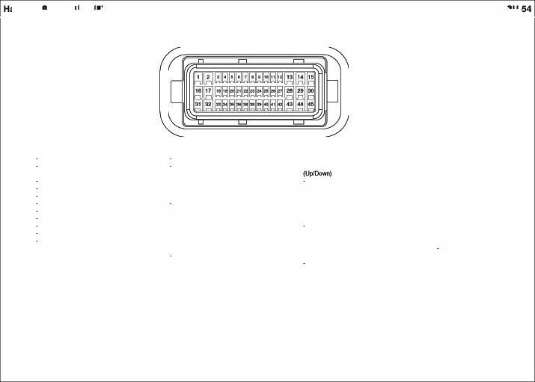G P<M'a'Out3id&Mrrot SMk:h (VA)

FD2 Fk>or To PUMngl Door H.,,.... COnntctlon (cont'
    - 45 Female IBia!:*(KET_HVS 4S _8)

I.- 1'UJ9 P$seenget Powel'Out3ideMrrct
2.- (Oelogge<)
3.0 PaeeEr'IQ8fDoocl«* Acll.lakW 17.G P$seenget Powel'Out3ideMrrct
31.8 G•OU'ld 41. A Pa&8E1'199' Sid& Impact Paeee�Powerwt'ldowSwltcl\. ......, �
Paeee�Ooot lO(:j( Act.la10t 42.l Pa&8E1'199' Sid& Impact

'"' -
Paeee�PowerOutside l.l,
....., (LOW

•.- 19. -
··- 20.8' P$seenget Door Loc Actuatot
&- (Keyl.OCI<)
7.- 21.G P$seenget Door Loc Actuatot
8.- (Key"'10ciq
··- 22 -
10.- 23
11.- Hanel&(Al'*IMl-}
12.- 24 Wi9
13. l PaeeEr'lQ8fPower WW'wJttw S� Hanel&(tock
(8' 25 P$seenget Door Loc Actuatot
14.y P88$EW'lQ8fPower WW'wJttw S� (Dooll.Ockftlnlock)
15.G PaeeEr'IQ8fPower WW'wJttw S� 2&-
27
.... _........ .... Pa&8E1'199' DoolSc:>eaJcer
"'"" W/OAlll' ·
..,0-.
32.P Paeee�PowerOutside l.llnor Pa&8E!fl99' DoolTweeter
(Tumlaflll) Sc:>eaker(+)
>l.l Paeee�DoollO(:j( Act.la10t 44.l ·---(·).
(AclualOI) W/OAlll' ·
34.- Pa&8E!fl99' DoolTweeter
36.°"" Paeee�Powerwt'ldow Switch Sc>eal«<!-)
(000<""'""(Uhloc� 45.-
:l6.LJ9 Paeee�PowerWhdow Switch
(000<""'""(l.CCIQ
'7. -
:l6.AIO Paeee�Powerwt'ldow Switch
(l.L>)

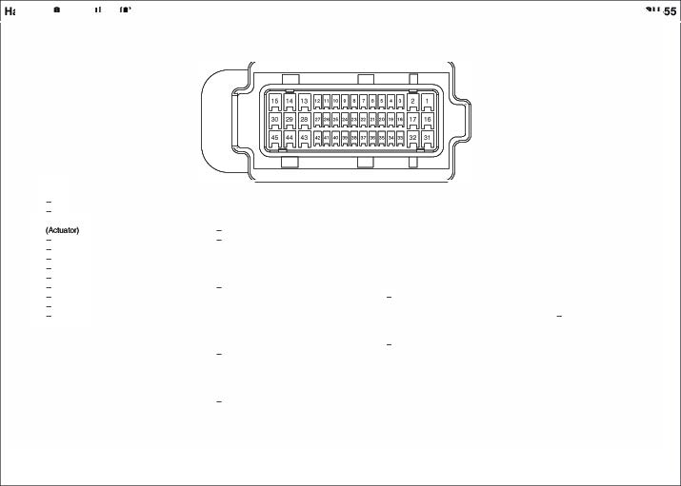Handle(Al'*IMl+)
2"'G< P$seenget Powel'Ou'3ii1eMrrct
... . P$seenget Powel'Out3ideMrrct
30.-
... .

<O.l
Wllh AMP· Paeee�Doolrwee.&t Speeket (•) Wllh AMP·
-----(-

FD3 Fk>o To RHr Dor
LH Hlml Conntetk>

- 1S�/Whlle(KET_�IL15M_W)
•15FEm81e While(KET_�11_15'_WJ

I.L  2.0 | llP.)Jfdion Sox(DOOfI.Hock Aiolay llP.)JfdionSox{Dool'Led Flelll!Y) | •. a. | Power WintJawMo.flSMkfl (Rew Wndow $-.itch 1.H) | 1.L  zo | Al Al | OCK>f Led AceuatotLH OCK>f Led AceuatotLH | •. a. 10.8 | AIN Pl:rwe WndrHISwikf'I AIN Pl:rwe WndrHISwikf'I
3. -  4.Y | -  IPSConniMc::dM | I1. P | °""nd(GFOO}  Power WintJawMo.flSMkfl | 3. -  4.Y | -  Al | OCK>f Led AceuatotLH | 11. p | (IU..•)  AIN Pl:rwe WndrHISwikf'I
•.8 | (°RN Door 1. l.Dc*Jlkllodt$9'11)  �(GF02) | 12. M> | (Rew Wndow $-.itch 1.H)  �pJl.o:lion Bo IP$3 (l.L.) |  | {l.CICkl\.H:lckSwi  Rl OCK>f Led AceuatotLH |  | IZM> | AIN Pl:rwe WndrHISwikf'I  (IU.. +)
.. . - - {l.CICkl\.H:lckSwi Grcwd) -
7.-  &O | -  llP.Aildion6ox•P/WrfW LH2$A 15.8 |  | N.MfoIAJllP' Fl. (•)  N.doAJllP .Fl. (o) | ... 7. - | - 14.y  - 1$.8 |  |  | AIN AIN | DoorSc>u DoorSc>u | 1.H (•)  1.H (•)
 |  |  |  | 8.0 | Rl �Wilckl Switc l.H (8+

F04 Fkl To Rea DoorAH HameeaConnection
• 1$....,�(K£T 1$M..,W)

I.L | ""....-....(llOO< ....,..Amy | 9.0 | Power M'IOO'wMainSMk:l'I |  | 1.L | AEIElf000t Lode AttJatorAH | 9.0 | Rea Powe Window�AH
2.0 | '1P.)Jf'don Box{DoollO(:j( Aelay) |  | (Aeef Window&.itch Ali) |  | zo | AEIElf000t Lode AttJatorAH | 10 0 | Rea DoofS(>eakefRH (+)
3.AIO | '1P.AlrdonBox •IPS3(1LI- | 10.G | N.l<loAMP | AA ..) | 3. Fro | AEIElfPower"W9'ldowSwitch Fli | 11.0 | Aea Ooo<-AH(-)
•.y | IPS CoorOIUoctA& | 11.0 | N.l<loAMP | AA(·) |  | (l.L•) | IZ- | -
 | (FleerOoot AHLocklU'*dc$9181) | 12. - | - |  | •.y | AeEW000t Lode AttJatorAH | 13.- | -

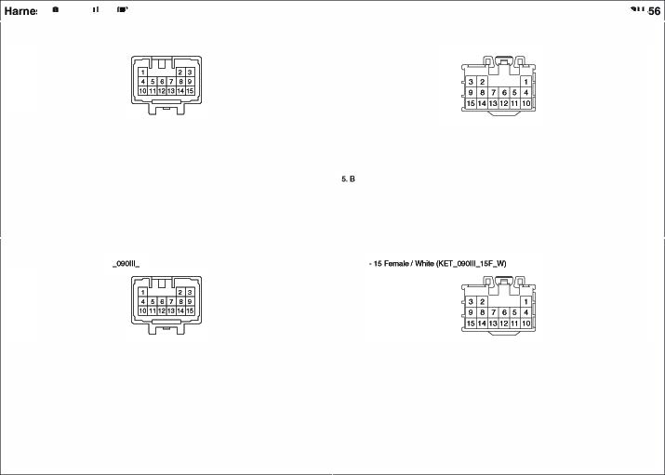•••
...

7.-
...
QOW'ld(QF08) 13. -
POWf'JIWindowMai s� 14. -
(FleerWlnclow SM.t:::l'I AH) 15.8
-
'1P.AlrdonBox•P/WrYW AH2SA
-
-
a'''""' (OF<le)
5.8
..
7. -
...
AEIElf000t Lode AttJatorAH 14. -
AEIElfPower"W9'ldowSwitch Fli 1&.8
-
AEIElfPower"W9'ldowSwitch Fli

(B>
-
Rea Powe Window�AH
(IU.-)

FR11 Fk>or To Tall Gal• Hlmtu COnMCtkln
-11�/Whlle(KET 80_17t.4

•17FEWl'l&le While (KETj1Y81809 _11F_W)

1.l l/P.)Jf'don8ox EAAR1SA
2.Br KMAeiey Box(Aeer �Reiay
3.W ICMAmyll<»(-W\l«Amy
4.W/OAN& �ab
Y/8 E�Ouom6cMitT0t (\/ldeo ON ·)
11.W/O NY&Ni!!Mgaion
Y 9elctroClvOtl'icMrrct (Vldoo PWR -t-
Wllh NY&Ni!!Mgaion
Y NV& Navigation Heed Module
(Vldoo PWR -t-
1.l AEIElfW�Moto 11.y ..,,...,..._
�8' AEIElfW�Moto (Aeet VIMCemera &.).
3.W AEIElfW�Moto l�G Rea De6ogger" (•)
4.VIS "",..._ 13.Y/9 ..,,...,..._
(AearVlewCemef ON (I'allGate Hendle S'Mk:h)
5.- 14.l TaiGa'9Latch

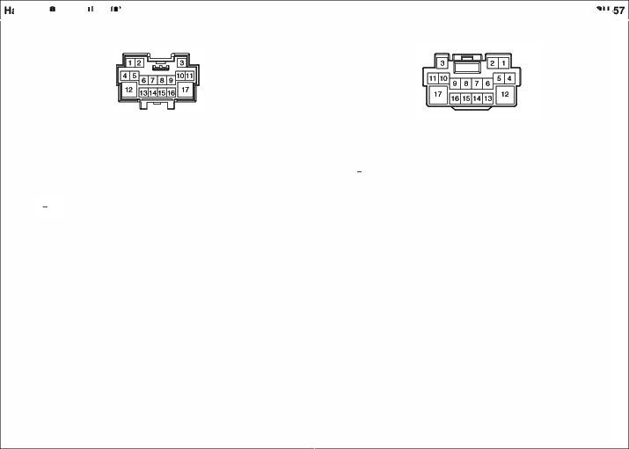Wllh NY &NEMge.ion
Y/8 M/&N�HeadMocU&
(\/ldeo ON -)
5.-
6.W/OAN& �ab
A E�Ouom6cMitT0t
(Video 10) WllhAN&�ab
A Ml&N� HeadMocU (Video 10)
7.W/OAN& �ab
Ml E�Ouom6cMitT0t (\/ldeo llOt<D
WllhAN&�ab
Ml Ml&N� HeadMocU
(\/ldeo llOt<D
&.G IPS CoorOIUoctA&• IPS7
9.Y IPS CoorOIUoctA&• IPS2
10.CW KMFteiey Box(OS Aelay>
12.G EIR Fuee&Aeiey Box
(AA t<IOAeloy)
13.Y/8 SnwtKeyc.oiwol MolU& (fall Ga•)
14.l WP.An:tlon Box(Tall Gate Aeiay
15.w 1PSControl Modi.le
(fall Ga•OpenS'Mk:h).
LuggSQ&Lamp
16. A WP.An:tlon Box

(llacl<.U .._ ""�
17.8 Ofound (GFoo}
6. "",..._
(Aea ViewCemet
1S.W
. CV8S (reil<l81e()pM._.
 | 16. | Back·Upl.aftl>LWFI
VQ«J.) | 17.8

7.Ml "",..._
(AearVlewCemef
  - Tall LampUlUoenseLamp
•.y Tall LampAH
10.G'B ............ Slop.._
TaiGa'9Latch

.. Oelogge<(-)

Fk>or To Bwnper Hllr'ftfl
conntctlon

•2Mala/Blade •2Femaia/Bl&c (t(UM_NM'WP_0'2F-8)

1.e | Sma i<.y Control Modul4t | 2. w | SmaltK*t' QndMcK:Ult | 1.e | SmlrtKev9UTp,,,,....,. | 2.w | $rnw1 KeyBu'rc> Anlenl\I
 | (ailf'l)CIJ ANT) |  | ---) |  | (&.m...ANT) |  | (-AHrGNO)

FS11 Fk>or To Drfvll' SHt Hllr'ftfl
COnntctlon

    - 22FemaleI White (KET_090111_2 _W)
•22Mala/Wl'il& (t(ET_090-2_22M_W)

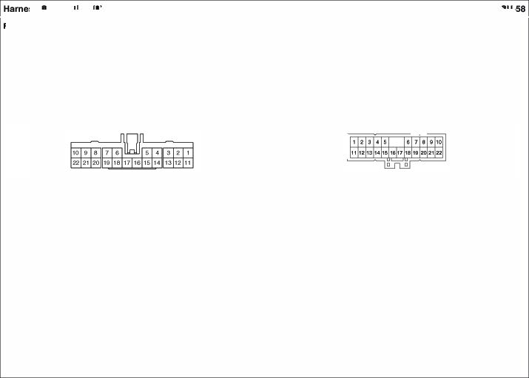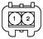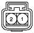

1.- - 12. - - ... - 12.- -
·· - - - .. . - 13.- -
3. - - - 3.- - 14. - -
.. . - 15.- - 4. - 1$. - -
•. Coos*Switch 1&.13< """""' - $. R on.... S.. W.arrnor 1&.BIW 0.W. Su.Iw.tm.
(O,W,,1S- Wwmer Fldwt• �) ([lri\oer $MtWi./TtWl!f�) (INO.•GNJ
&.L 17. - - &.Y on.... S.. W.armtllf 17. - -
(O,W,,1S- Wwmer Fldwt•Low) - (SMkfl • Lo 18. - -
7. - - .•. - - 7.- - 19. - -
e.e �(GFO .. . - ae on.... S..W.arrnor(ONO ... . -
·· - - 21. - - ·· - 21. - -
10.8 �(GFO 22 - - 10.e on.... S.. Ml,...alSMkfl (GNO), 22.- -
11. R llP.Alldi:lnSox• on....Adling1.irritSwiktl(GND)
(ORV)20A II, A on.... s..""',.....SMkfl (S.).

MC11 UolnTo COnt ..n
COnnedlon

•24�IWhile(KUP.UISC W)

I.-  ··- | 13.G | CNiM Aornallteo.dSwitc | '· -  z- |  | 13.G | EIFI fule& AiolayBo • ECU27.5
3. - | 14.• |  | 3.- |  | 14. -
4.W'8 |  |  | 4. """ | PCM (Ergile $peodSignal) | 1$.-
·· |  |  |  |  | 16.-
 |  | E$ Off �h | .....,. |  | 17.0 | ESC �(E$ Off
$peodSigl\lll POM 8< Vehid9Sptod$en5ol" S- 'ON)
7.L SAS •Pa™""!JOf | FIS (High) | SAS• .,_nger AS (Low) | 1.L | .,_nsi Fron lr'ltlf»c $ensof | 18.P ESC �(v.tioel

a. :io.
··- 21. -
10. .. ... .
11. 8 CtWse Flemo9Control Switch ....
oecs-
Sc>ot»d$Gn50fOutput(RR)
a- 19.0 P•�• Hant llf'l)ld Sorl50f
·· (Lo
:io. esc ......,

(Ground ....
PCM(CtMl.i
�Swilc (OOC Switch 'CH

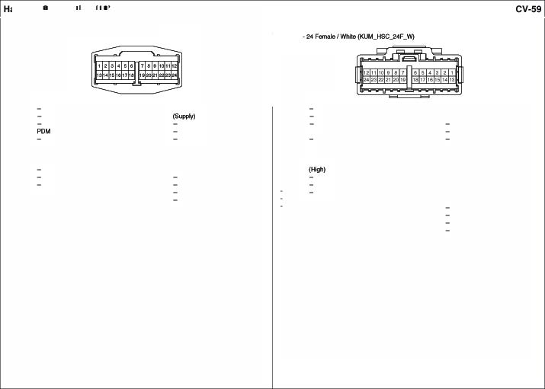IZL CtWse Flemo9Control Switch (-
PCM(Ctl.i CDd$wilc $igm 21. -

n- 23.-
24.-

•22�/eiua l,l(ET_ooo11u:210.) • 22FEWl'l&le Blue (t(ET_090llL22FJ.

1.0 C. (I.ow) 12. - - 1.0 CCAN(Low) 12. - -
(DUI l,Sl | Connoielof) |  | - | (ESCModul-. PCM_, 13.- -
- |  | 14. | FrontWqh1 Swilc |  | ..._°""".,.._) | 14. | Front W&sherMot::w
- |  |  | ANi- WashorSwikf\ BCM | 2. | - | 1$.L

·· -
3. -
4. - lnmment cius. (Fuel S.ncklt 3.- - 16.0 PCM (Fual T&ntlLewi S.ncler

·· -
&. | tCMAioky Bo | (06 | Flelll!Y) |  | - | $. - | - |  | -
7. - | - |  |  | •••Wr6 | K:M Flelll!Y8ox(09CRioky | &. | ESCMach• | 19.w.v | ESC ......,.
e. -  ·· - | -  - |  |  | 20.-  21.U.IO | -  1nmment CluAl (IMMO, INO.) |  | �J.b#ltod Stop l.M'c>.  $lapl.wn IJ(l1=I | 20.-  21.BtlO | -  PCM (IMJMl

- ··- - 17. - -

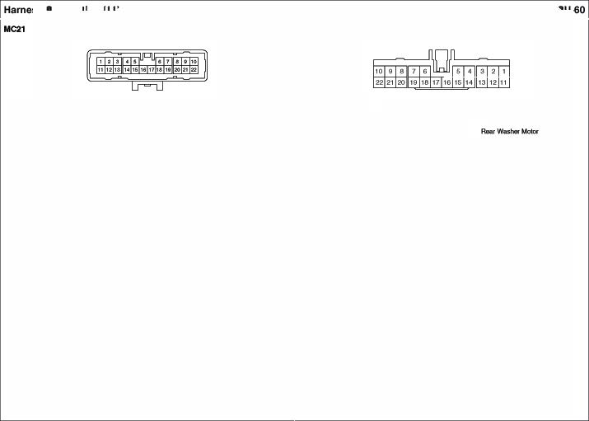
10. .. - ... - - 7.- - 22.- -
11. G C. (..,,.) e. -
(DUI l,Sl Connoielof) ·· -
-
II, G C. (M;gh)
(ESCModul-. PCM_,
..._°""".,.._)
NJ.)

MC3 UolnTo C<>nt ..n
COnnedlon

•24�IWhile(KUP.UISC W)

I.- 13. -
••Ml POM ($tw Hied��
3.0. AICCcNdMCICUI (ECVIN) t5.L
4.Viii lnA'\11n1ntC.tor.s
(Chod<- 1<0.) 17.08
··
tCMAiolay Bo (De Flelll!Y)
1.YJS -......co- :iO G•
(Oil p,._..N> 21. -

AICODd �(ECVOIJT)

9CM(Wipo< ""'"(Low)"°'*°'>

MUtir...danSMkfl (1-bm SMkfl)

'· - 12.W °"'"' Ffont llf'INICf s.isc.{l..ow)
2.Ml EI �M& Aday BoK 13.-
IS"" ...,.,) 14. -
MIT•PCM (S"'1°"""' (P()o,1)) 1$.L AICConl><.,... AICConl>< """' (�CDdVINe
(Elec$iclillCcNdV&l\4(•I) 16.-
4,YAJ PCM (Chee* Engilo INO.) 17.08 EIFI fule& AiolayBo
$. - (WiperFRT, LOFlellf!Y)
&.O Skil>l.wn Swikf\ ESC Moch• 18.-

8.Ml 4Vt'OECM(CfART
liM ... .
Ol�Switch 19. -

•.w 0.111Li.. Ccnnect::w(9odyK...il'lf) ....
10. .. ....
11. St SAS• Orio. RS(Hig
  - SAS• Orio. RS(Low)

•.w
ll'P ..k.nction8ax•MCXH.11.E I IQA :iO.G• EIFI fule& AiolayBo
(HornfWay
(9ody K·Li"'I 21. -
....

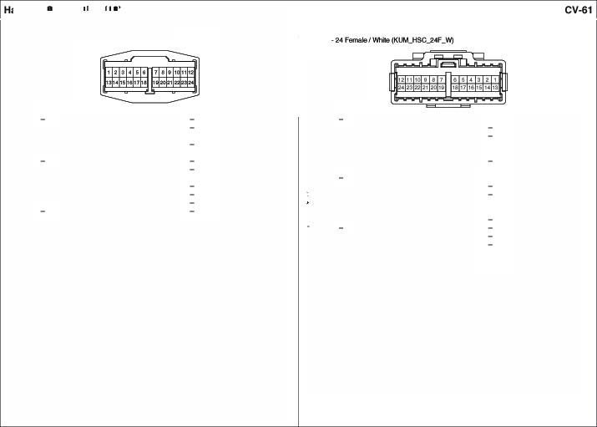11.& on.... Ftcn tlmf»c $en5ol"(�) 23.-

24.-

    - 15Male/Sloe(NIP_ons 1SM_l) • 1s f.emaletEIJe(AMP_ons J.)

13

1.Wllh SmartKey 8.L lmmct>ilit.9 Mc:K:klllo 1.L PCM (IMMO. OI» Line 8.L EMS Bo SEHSOR IOA WiO Srna K�Conllol Mock119 .. . - 2.G EIA Fuso Allay 6ooc ·· - -
W/OSmartKey ICM Rela.ySox (OOC Fkilll!Y) ("'"""-· 10. L E1A Fuso Allay9:111•
L lrmlobiaf MCICUI 11. A Will SmwtKtJt• 3. Ll8 AIT()ienf Sol'GOJ STOPl. IOA
2.G F«r'lt Wlp&f Deiol!r&Mich (IND.) P0)4 ANyBox (K>H Rl! .."' An't>il!n Senses 11. R EI Fuse �y Box·IGH 4C>A 3.UB NCCtiMdMod W/OSnwlKOJ•lgrilionSW::fl .."' EI Fuse&Aday Box 12.P EI Fuse �y Box·IGH 1 3C>A
(Ad>il!n Senses(•)) 12. WllhSma l(ey (� FRT LO ANy) 13. - -
NCCtiMdMod p P0>4 RNyBox (K>H Rl! •• ...._ 14.G Fron tw� Mok>r (low)
- G«•rd) 13. - - (�"""YI 16.B
FfOl'l W¥>$'SMdl 14.G F«r'ltWlp&f Swilc (Low) 7.P Fron � Moeot{Kgh
... FUl!I Pu111>Mob 16.B llrwnobib&f J4cMt.lle
7.p FfOl'l W¥>$'SW::tl (�

Uai To Cont Ham Connection

• 1 Male v.tiite{'KET..,581.....0IM.W)-
I Fem /v.tiite ('KET..,581..,.0IF..W) •I Fom*/Whitlo(KET,.$8l.,OIF..WJ

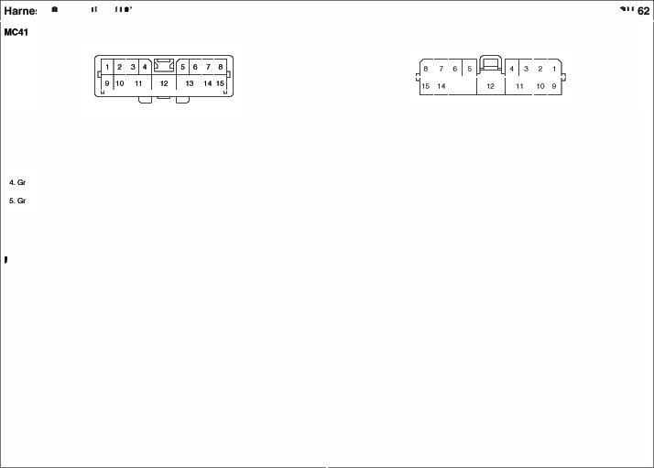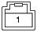

I.A EIFIF..,.&, Aioky Box• MOPS 80A I. A EP Conlr (e.tt.yPOWGr)

MF UM\ To Floor Hllr'ftfl
COnntctlon

•24�/Yelow (KUM_HSC_24M_Y)

I.A.ti�.)Jnc9on8ox·SUARTKEY 10!\ 13. -
14. -
2.-
3-Wiii PC»A(a.IMO Oeta) 15. -
4.Yt'B PC»A(a.IMO Clod() 18. -
1.Ml 13. -
� - 14. -
"'Wiii Fob Holdef(ldMO Dela) 1S. -
- YIB Fob Holdef(ldMO Clod() 18. -

- Pt'B PC»A(Holder IU.)
17. -
.. Piii Fob Holdef(LL+) 17. -

8.0'8PC»A(FOO '1 "'Fro
19.L/O
&- 20 Wiii
9.0 CCAN(lOW) 21.0
(0&18. ll'l Connectof) 22
10.G CCAN(tl) ""-
(0&18. ll'l Connectof) 24 -
11.-
ATM SMtl&tet (l. +) 6.0'8 Fob Holdef(FOO '1 18.Fro ATM Shift l.8Y8fIU. (LL•)
ATM SN1tl&ter (l. -) 7. - 19.L/O ATM Shift l.8Y8fIU. (LL+)
ICMRelay!lox{Re8t-Relay) 6.- 20 Will IPSCcwWol MOCUE mtrumentClulM&f (Fuel Sender.,.) 9.0 POO (C-CA LOW) (ReelWll* Ael& CCIM'd) mtrumentClulM&f {Fuel Sender·) 10.0 POO (C-CA HI) 21.0 fuel Sender (•)
11.- 2�e Fuel Sender (·)
12. - 23.-
24. -

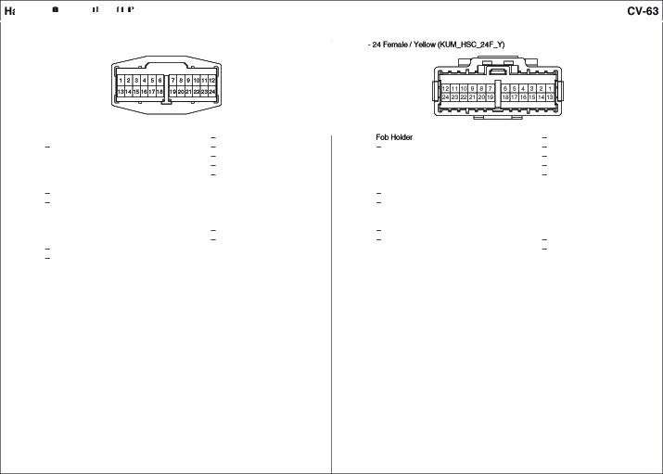
·�-

MF21 UM\To Floor Hllr'ftfl
COnntctlon

• 24�/G1ay (KET_O«>ll_24M_GA')

I.-
2.-
3.-
4.WJOAN& �ati:::n
YIB Ek!c*o cr1nic1o
(Video GN ·) WilhAN&�ati:::n

Uih'ot

13. -
14. -
16.WJOAN&NIMgaion
R EleolroClwcmcMftor
(V-"l
With AN&�ation
R NV& teigalion Heed Module

I. - 13.
2. 14. -
3. IS. R .........'-""'
4.'"' Uoerls.elamp (Rl!el' ViewCatneta•C\l8S)
{Reef Viewcamera· GN 18.R.B .........'-""'
5.Y Uoerls.elamp (Rl!el' ViewCatneta•VGN
{Reef Viewcamera· Bo) 17. -

YIB AN&N�HoadMocU!
(Video GN ·)
6.WJOAN&�ati:::n
(V-"l
t6.WJO AN&�ation
FW EleolroClwCll'MMftor
8.G Salt!tf�WindowModule(COM 18.
7.0 4WD ECJ4(C-CAN �) 19.y 4WDECM (4WO Loc &Mtch a- 20.G 4WDECM (c.cAN (High))

Y Ek!c*o cr1nic1o
(Video PWR. •)
WilhAN&�ati:::n
Uih'ot
(Vicb> VG
With AN&�ation
1W NV& teigalion Heed Module
.. - 21. -
10.G DoorLockActuah:IJ's 22.-
11.- 23.""' 4WDECM(8t

Y AN &N� HoadMocU!
(Video PWR. •)
6..G SCI.I(Safety PowerWindowLbl.M)

17. - 18.
(Vicb> VG
12. - 24. -

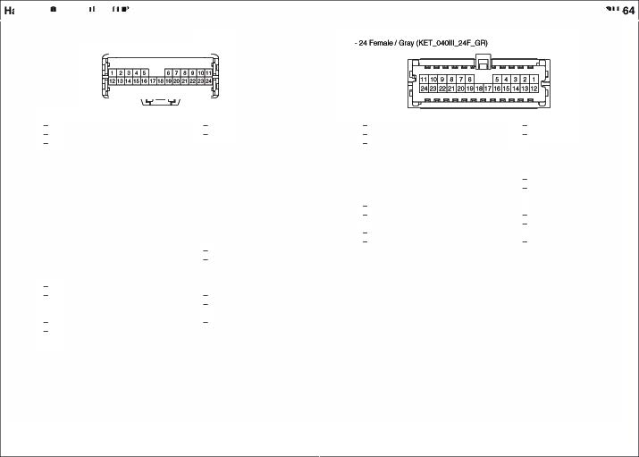7.0 C-CAN (low)
(Da«a U'l Conneolor
a­
•.-
1 0.G tCMRela Box
(T....oTum Unloelc Rl!lay)
11. -
12. -
19.Y 4WO LockSW::fl 20 G C-cAN{Kgh
(Data u-..Comedof)
21. -
... -
- RO WP.Mclion Box· TPM 7.6A
24 -

MF3 UM\To Floor Hllr'ftfl
COnntctlon

• 22�/eiual,l(ET ooo11u:210.)
  - 22FEWl'l&le Blue (t(ET_090llL22FJ.

1.Br Coneol&s.itc
(Orh<e Se Warmers.itc
2.w Coned&s.itc
(O-Sea1Waome<Aei8y High
3.l Coned&s.itc
(Orh<e Se WarmerAel&/•L.cnir')
4.8 Auelb(Aeef LH Spetllkef-)
5.Y Auelb(Aeef LH Spetllkef+)
&-
7.-
&.W Auelb(FfOl'lllH Speake ·)
9.Br Al.db(FfOl'lllH Speakef•)
10.-
11.-

12.w Con901e S•
(Pass. Seat _,. Hig
13.l Con901e S•
(Pass. Seat _,. Low)
14.8t K:MAelayBox(Fteat Wiper"Aelay)
15.w K:MAelayBox(Reat Wiper"Aelay)
16.W/O NY&Ni!!Mgaion
l -

Wllh NY&Ni!!Mgaion
l NV& Navigation Heed Module
(CAN-High
17.W/O NY&Ni!!Mgaion
. -
(CAN·I.OW)
Wllh NY&Ni!!Mgaion
A NV& Navigation Heed Module
(CAN-High

1.8'
�w

aL
•.8
5.Y
a- aw 9.8'
7. -
10. -
11.-

Ort\<ef SetlllWartret(HI Q«> 12.w ---
Ort\<efSetlllWartret --Hig
-·High) 13, L ---
Ort\<ef SetlllWartret(S-Mk:l'I • Low) --low
-000< -LH(·) 14, Br ---
AEIElf000 Speeket LH(+) 15,W --- 16, L
11. R AM (CAN low)
"""" 000<-(-). 18, -
19.G --
Ort\<ef Ooot Speeket (+). 20.R/8 <W ECM (OmTAAT1.-.ul) Ort\<ef Ooot��(•) 21.P FuelPun Motor
22.-

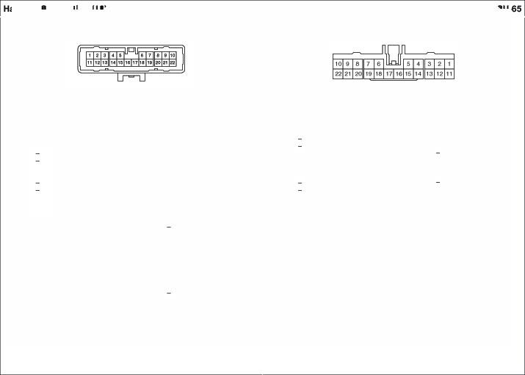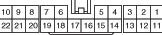'"' -
19.W/O NY&Ni!!Mgaion G -(Ar<eM&j Wllh NY&Ni!!Mgaion
G NV& Navigation Heed Module
(An"""')
20.FW WP.An:t1on Box·YOOLl. 1 10A
21. P EMS8ox
(F-Aelay)
22.-

MF4 UM\To Floor Hllr'ftfl
COnntctlon

• 24�/G1ay (KET_O«>ll_24M_GA')

1.81 Ccnsde&Mtch

13.WJO AN&�ation G ......,

....
�-

�&91 rrret(NJ.·GND) 1�G
14. -

NAP (SPO ·OUT(-}

2.-
3.A k'Ulll'lel'll�(&CAN 1,1.o.)
4.8110 k'Ulll'lel'llCl.Rr (l>M.IO. INO.)
6.0 Audi:>(Rl!9 RHSpoa ·)
6.l Audi:>(�RHS�·)
7.WilhAN&�ati:::n
81 AN &N� Head MocU!
(NEVI Voioe ("))
aWilhAN&�ati:::n
B AN &N� HoadMocU!
(NEVI Voioe •5rlil!kl GND)
(SAlF·OUT (·))
With AN&�ation
G NV& Nalligalion Heed Module
(SAlF·OUT (·))
1� -
15. -
18. -
17.GIB BCM /1{.tJY lnb Loc &Mich
18. -
19.l hllunl!n C....,,(&CA (High
20 WJO AN&�ation
�·

�
5.0
8.l

7.8<
...
.. -
10. -
Smar KeyCcinb'd Mocllle
(l>CAH(Low))
Smar KeyCcinb'd Mocllle
�000t Spl!ekef RH(·>
- Doo<-(-),
- Doo< T""'*" Spl!ekef(-) AM (NEVI Voice (+))
AM (NEVI Voi:::e• �GND)

IS. -
,.. _
17.GIB

,.. _
19.l

20.W
21.G
·�·

ATM Slliftle'W!I ('P' Posilb'ISW:):fl

SmMKey 0on"1)1 �le
(8-CAN(�)
NAP (SPO ·OUT(•))
Rea1Docs�RH P4SSel'l9"f Door�(
·-­

··- 1 0.-
w -
(SAlF·OUT(•))
11. w.io Smar KeyCcinb'd Mocllle
(Body K·Un&)

·�y
T�
AMP(NEVl""Hl

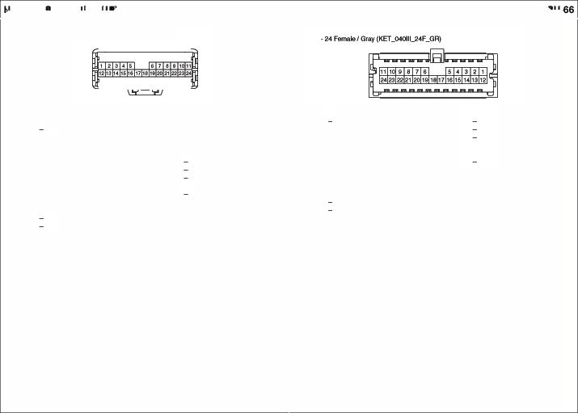11. WKJ Dala Ui* CCIV'll!Cb'(BodyKolin& 12..B Aucli:>(SPDF hidd GND)
With AN&�ation
W NV& Nalligalion Heed Module (SAlF·OUT(•))
21.G Auclo{Reaf RH Speekef •)
22 R Auclo {FfOl'l RHSpoaktor •)
23.With AN&�ation
Y NV& Nalligalion Heed Module (NEVI "°"" (·))
24 WJO PC'4 (IA4 Data Un&)
12.B
AM (SPOI ·Shield GNO)
24.W/O
SnmKey 0on"1)1 J4o<t.lle

MF5 UM\ To Floor Hllr'ftfl
COnntctlon

•24�/Yelow (KUM_HSC_24M_Y)

I.- 13. -
2.- 14. -
3-l Slart StopBunonS�(S'W2) 15. -
•.- 16.8118
··- 17. -
6.- 18. -

ll .Ancllon Box• YOLl.
1. - 13. -
� - 14. -
3-l SmartKeyCoo1re1 Moehle 15. -
5 7.SA (SS8SW2 16. StM Key Con•Ol"6Cd.lle
.. - {ONl'ST I�
5. 17. -

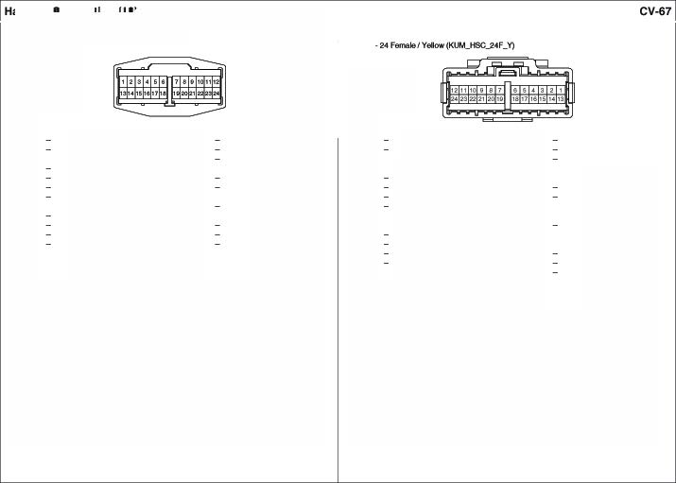19.0
... Smart KeyAlllel'lneII 20.-
··- 21.l
10.- 22 -
11.- ""-
24 -
·�-
·•-(llel8) 6. 18. -
7. - 19.0 StM Key Con•Ol"6Cd.lle
&nettKey •1 (ONO) .. . SmartKeyCoo1re1 Moehle IAF_COM
(htewklf_ANT1) 20.-
..- 21.l StM Key Con•Ol"6Cd.lle
10. - (lntefiorJHT1_0N>
11.- 2�-
12. - 23. -
24. -

MA0 UM\ To Root Hlml Conctne k>
• 22�IWhile(A.M _090ll22M_W)

I.Br
2.AIO
3-0
...y�

•.y
BCM(Room'-Conlrol)
l.l (•)
l/P .)Jnc9on8ox AOCIALP IOA lloen9e Lamp (FleerView CemEwa• GN
lloen9e Lamp (FleerView CemEwa• a.,.
12. -
13.W/O NY&�atlon l AUD
(MI
Wllh NY&�a.tlon
8 NV& Navigation Heed Module
(MI
1.8r Maplamp
2- - No IJ9ed
"'0 e.
Elect'o Ovomlc l.lrror Map L8q> Cld\«1Pa&8E1'199'Vanity l.aftl>, Aoomlemp
4.W/O
12.-
13.WIOAN& Navigation l AL<ltO
(MIC-)
W.. AN& Navigation
8 Ml& Nav198llon HeedMoch• (MIC-)

&l llP.)Jnc9onBox•Back·UpLamp
_,
1<1. A
15. A
ll .Ancllon Box SUNAOOF15A
VIS Elect'o Ovomlc l.lrror
(VldeoON ·)
14.R SurwoofMotot S.)
IS.WIOAN& Navigation

7.W/OAN& �ab A AUDIO
(MIC..)
(Aeef WewCamer •CV8S)
16.M � Lafll)
(Aeef WewCamer VGNO.)
S.W/OAN&�'*>n
Y Elect'o Ovomlc l.lrror
A 9ec Cht'ooVcMlttor
(Video 10)
16. WIOAN& Navigation

WllhAN&�ab
A Ml N�Heed McdA& (MIC..)
&­
..-
10. -
11. -
17.8t '"'8
19. -
20 G110
21. - 22
VeNcie SpeedSl{J'lal Ground (GYOl2)

ll .Ancllon Box• YOLl.ll .Ancllon Box• YOLl.

2 10A

4 10A
aL Elect'o OWomlc l.lrror
(Bed<·"' Sl11"1J
7. A
&-
.. -
10. -
11. -
Re 9ec Cht'ooVcMlttor
(Video VON
17.8r SurwoofMotof(VEtlSc:>eed)
18.8 Qouncl• 9elctroCIWOtl'ieMrrot SurwoofSiM!ch.&.'!'°°' Motor MapL81J'C), Aooml.alT'c>.

DtlPaaseoget v� 1.amp
19.-
- GilO 9ec ChlooVcMlttor
CON '1""1)

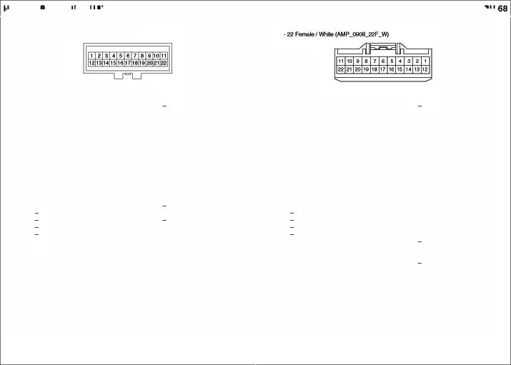21. -
22 0 SurwoolMo10f(102)

•18 Female White (AMP_0925_1f!/F _W)
  - 4FemaleI White(AMP_2SO_OI _W_SPT)

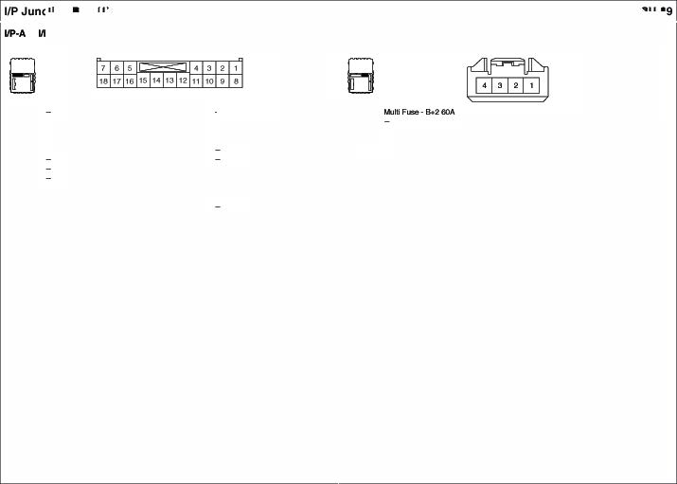
I.- 2.Y

3.-
4.-
6.­
...

7.R

WP FAT25A ·
Fron W�Motor EIAFuse &RNyBox (WIPE FRT,lOAday

tG 1 20A (OWSTART�·
EIAFuse &RNyBox
(ECU 27..6A/ABS7.6/TC 27.6)
Hot Used

.. "' 10.0
11.0I
12. -
13. -
14.G

16. R

16. -

FS0• Heed l..af11) RH(LO) FS6· Heed l..af11) lH (ti) FS1 • Heed l..af11) RH(HI)

EI Fuse & AdayBox (RR tfTD Aday
EI Fuse & AdayBox
� Relay)

FS6• Ffcnl Fog1..an1> lJfflH FS4· Heed l..af11) lH 1,1.0)

- R 2.-

3.R
4.W

MIAli Fuse Bo.3 8C>A MIAli Fus.e ec>A

  - 28FemaleI White (AMP_02S_28 _W)

llP· llPJw>ctlonBo
•<1 F-emara/�te (!t.1*_<tl _d_W,

8

1.y

IPS2(Tail • Re9 Ctlntinafo lamp 21. R

IPS3(LL) •PlWDW >.la S�

1.-

16.WJO Smar Kev
(Qui) AH, Rea Corna
(IN) RH
lion l.aq:>
�Power �Swilc
�� Wblow SWilc l.H/

2.-
3.-
4.WJOSmar Kev
P Wllh l)M.IQ.• ElftFute & Rl!
P VWOl.IMO • EI Fuse ANy Box(Stlr1 Rl!
1 .-
17. -
IPS7(Tail · Ucer1selanp, 22.-
�CornlWlalonlamp(OUI) lH., 2�WtB
�CornlWlalon lamp(l(l lH
Q.USTER 1 A· 24.GfO

IPSCol*ol J4cMt.lle• tCMAday
-- _.Rdoy"°'*")
IPSCol*ol J4cMt.lle• D� Door

800I (SW Ada
WllhSmar Kev
P WT EI Fuse Relay Box
1 .y

19.W
BCM (Tun& Haut La111>0U
·H!!edLampLH
BCM (Tun& Haut La111>0U
4. -
6.W
Smaf KeyConb'd Mochle (A LT• l)

BCM (Twn& Hazan:l l.an'p�

26. PJB
"""""
IPSCol*ol J4cMt.lle•Pas�
--

s.-
.-
7.G
.Y/O
(SWIRda
All•E/R Fuse & Aday Box (ATM PINRl!

Chaf91tIND., Diod ·�nelor (l) FuseMODULE 4IQA•

..
21. R
22

23.B<IO
·H!!edLamp RH Glout.i (GHG01)
FSControl Modi.le • Hood SWitch
FSControl Modi.le · Bac:*:
u,,., .-
FSControl Modi.le • Bt A.lid
,_..._

.-
7. R

av
·Reel'�n1..an1> (QA) lH, 26.GlfB
DIW �OuBideMiTor
27.y
SMARTKEY10A•
Sma Key �olLblJe 2a•
..wAG IOA• Pas�Clocupan Deb:lion S&nsol'
IPSCol*ol J4cMt.lle• Rea1 Door
Wk:hRH
IPSCol*ol J4cMt.lle• Rea1 Door RHlcd'/lktoc: �nail IPSCol*ol J4cMt.lle• D� Door Key lkllock Sgna
Col*ol J4cMt.lle•

EI Fuse&ANyBox
24.-
9.G
AUCl 21 A·
.....
IPS
DoKey
lock Sgna
Pas�

(E!lo'w&f Rl!
2£ FS2• Heedl..af11) RH
AM Smar KeyC:C...ol MocUe 30
IPSCol*ol J4cMt.lle•Pas�

•.Will
MODULE 1 IQA• S1op1..an1> SWilc 28
FS7·Heedl..af11) lH
PowerOVlside Uir11:> SWilc
DoKey
Unloelc Signal

10.RIB
12. -
MODULE 1 IOA · 4WO ECM
27 BtfB
28
FSControl Modl.fft• ESC Mod (Parking er
FSControl Modi.le
10. P
BCM (Tun& Haut Lalf{:> OU!pU) 31.GI
·Reel'�n1..an1>(QA) RH Pas� P�Outside Ml1or 32.W
11. WJB 12.G
IPSCol*ol J4cMt.lle• D� Door loclrlUnlock Spl IPSCol*ol J4cMt.lle•Pas�

IPS �olUc:dJe�I Alai
(Oeioel" AdayCol*ol)•EI Fuse&
TPMS7.liA·ATM 5rliltleww
DoL.ocM.H:
kSignel

HomRdaf Col*cf)• EI Fuse&
AdayBox{Deio&f R!!IAIJ)
FIOC».4 LP IOA•l. La 33
IPSCoc*tll Mc:K:klllo• AN.1 Door

Rela Box (B' HORNRNy)
13, -
l.M l.kl\J
ntodl $91al

14.GIO
IPS �olUc:dJe(RMiDetoggie.' Rela Control • ElftFute & R!lay 800I (RR HTD ANy)
16. - 17.0
19. Y,V

F'SConltol Module• OriYerSoat
9'1t�klloSMkfl

F'SConltol Module• Roa Door
34.R

36.YA)

36.G118
IPSCoc*tll �19• DM1 Door
""'"°"'59>
IPSCoc*tll Mc:K:klllo• Smalt KO'f
eo.dt.bUI>,TMGI.a Hench
-
IPSCoc*tll Mc:K:klllo• Doof lkllock
-

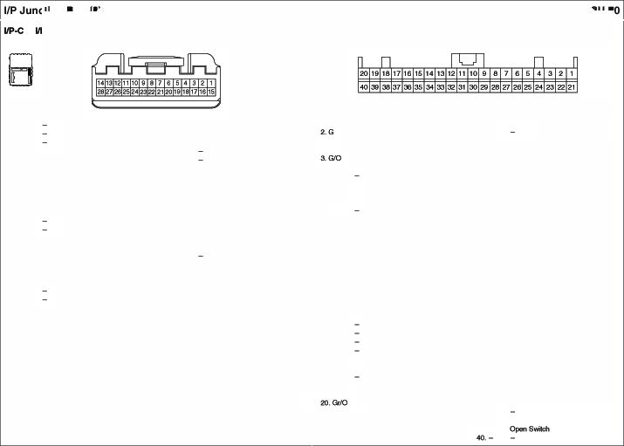Switch LH 37.IAJ
F'SConltol Module• Pwk'1g Bt
s.riW 38
...w
IPSCoc*tll Mc:K:klllo• Doofl.cd
-

IPSCoc*tll Mc:K:klllo• Tail Gate

• 20 N!Jmale/�le (!t.1*_0925J<)F_WJ

llP• WJW>CtlonBo
•28F-emara/�te(!t.1*_<¥l5_2BF_W,

I. R

�­
�­
Bad: LampR!!IAIJ •Aeaf
Conti\alion l.aq:>(IN)l.H/R
11.UB

l�l
HT MIRR7.liA·
o��PO¥fel'
ClutsicleMSrcr (Oe6:iggef)
WIPE RR1SA. Re9'w� Moler

I. "'°
�·

TPMS7.6A· 4WDECM TPMS7.6A·

l�-
14.GllO UOOU. 210A·

�­
...

GrW'ICI (GF0
i�o
l�G
JU.JP 26A• AMP
E/RFuse& Rela Box
Two
Pres9.1re
Monitorr.g J4cMt.l
IS. -
Ell!ct
Olroric "''Ot

6.0

7. R
PIW LH25A·
�Window Main SW PIW RH 2S •

15. R
(RR KTDRelay)• A'9r Oe1ogges(" P/SEA (DAV) 20A
- O!Wef Sea M•ua SW 5.
16.P

17.
BO.I•
<">"
TurrvtlazardLamp�

8.l
�� Wblo SW RH DoorUnloelc Rl! •
16.y
SAFET Y POW WIDO 20A•
Salety Power \'\lbbiLbUe
6.G•
BCM •TwWHata.d lanpOU
(R.)
-
18. -
19. -

�/Rea l.H/Rea1 RHDoor
17. -
7.VIS
BCM •TwWHata.d lanpOU
20.-
-

9.0

10. L
.__ __
DoorLock Rela · O�I
�LK1AMiAH DocsW*
"'""""
Tai GateRela Tail Gale La\l::tl
18.0

19. A

20.l
PIWDW LH25A •
Rear�WlndowSMdl LH
PIWDW RH25A ·
� Wblo ManSMdl, Passerl9&f �WlndowSW::fl POWE OUTI.ET2 26A•
Rea1�0Ul&t

av.,

9.W

10. -
11. -
(FR)
FSControl Module • Two Tun Unioi:::* RNy FSControl Module • Head l.aq:> Low�tch
21.
·�­
·�-
24.G

- RAJ 26.-

KTDMlAR7..6A•
......_._
IPS amnellon

12.0
MOl.l
.E410A
27.W
uoou.e
210A. P[)M

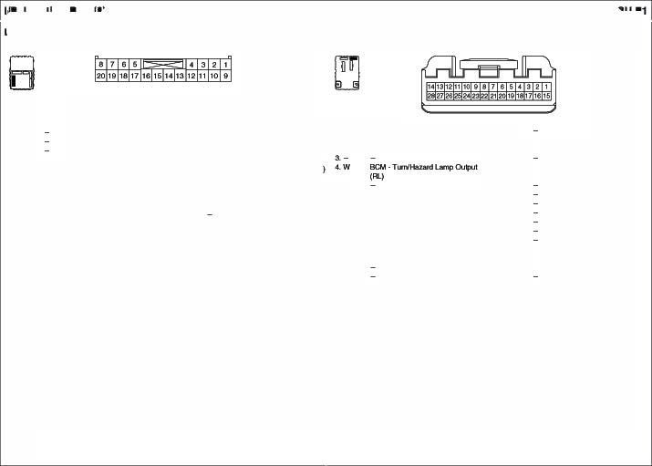NC�olUcxU&
C� kril,lM SUNoof Mob
28.G
uoou.e
210A. BCM

llP•H l/PJw>ctlon Bo
  - 18 F-ema/a/�te (AJ.IP_092S_t8F_WJ

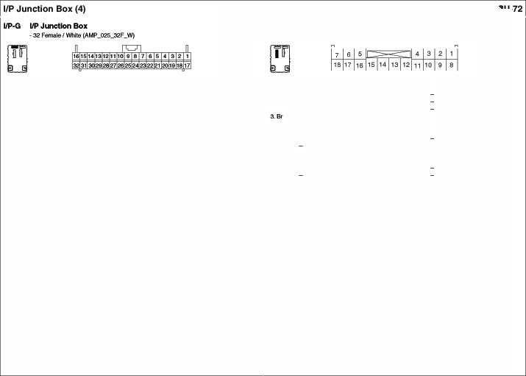

•$tw1 $b:lp Swilch
8.G 0.lrfg9 NJ AL (L)
9.G1IO MOOUl. t IOA•
TR PrHSl.Q �MCICUD 2&.13</0
10.R MOOUl. t IOA•
EPS Con11o1 Mockillo
- 27.UO
-
13.M 8ac*• l.Mn Flel"f •ec:M, ... .
AN&NwvigallianHNd MocUrt ....
14, - -
1s.UO AUOI0 30.-
AN&Nl:wi!gaion� ModMI 3t.LIO
16.UO AUDIO210A• 9CM POM 32.-

-
1. -  ZG1IO | -  Q.USTE'R IOA• | 17. -  ,.. _
 | 1�0..S.(INO.>  �.-. | ""-
a-  ··-  .. ""  &. | -  -  SMART KEY IOA·FobHatler  - | 2t.W,fJ  22.""'  2ao
7.L | SMARTKEY IOA | 24.G

-
Cl.USTE IOA• Jwcio
-
SMARTt<EY IQA• t<.ySolenoid SMARTt<EY IOA• FO Cl.USTEA IOA •
AN&Na.v9alion HHdMoch•
ec:M, ALT(L.)
MOOl. 1 IM•
ESC08 Swilcl\. OOC &.itch, K:MAday Bax(D9C Reily) MOOl. 1 106.
Ml.AilutdanSMkfl
(T Signll L.a1T1>$'Mktl) Al8AG IND IOA • lnsltl.rl'IGn Cha•• (AirSagIND.)
A/CON 7.SA •NCConllol Mo<tll9
S.ck·�Y.111> Rioky. a.ao
ClwolricM'""
-
At.l)t()2 10A• Auclo
-

1••
....

�·
5.
....

7. -
..

IPSConlJOI Module•8-CNf(l.owt HAZARD 16A·
CM Rl!layBox(Flasflel' SoW'llS
Relay) BCl,I
Module7.6
BCM, PDM,
·
Sma Key�olLbUe P[)M 16A·PCM

OR LOCK 16A·
CM Rl!layBox
(TwoTw lkllockRelay)

FSControl MCIC!Ue •&CAN{Kgh

•••
10. -
12.-

1 . p
15. - 16.L

17. -
18. -

G1CU'ld (GM02)

EIAfl.de&Rl!IAIJBox (Bower Rl!lay) •Elowe1 MotcS OWSTART k\pu

A/BAG10A
•SASControl Modi.ff\,
Teltabl..af11)

• 16 N!Jmale/�le (Al.IP_0925_1eF_W)

1.G

AOOM IP IOA
A'*>ligh &Pho Serlsor DalaUi* Comedot J4ap �. Room lM'p Ori\'eS/Passo'19"'
Van lM'p Elec*o OlrorricUifOI POW OUTLET:225A ·
Qgafeftelighk!r & Front
_,,..,
SIH FRT 16A
Cc:nscll!&Mich

8.A SLl*IOOF15A • &Root Moto
  - G POWE OUTI.ET 1 16A
    - Cigatette U(lflie.'&
Flcn Powe OUlle
U),- -
11.W
11-� Snw Key
R STARTI..
W/O Stnei Key
G STARTI..

4. -
5.Y

6.-
7.G
•

WF FRT:25 •
Wlib'lolion SWilc (Flcn �>

ROOM: LP IQA•
lgrilionKey Ill & OoG' Waning
1�l ONk'lpul
14. R
�ANNavfgalion
AIV�alon HeadLbUe
W/O AN Navigation
,.._

S.-
ld\AIC Conlrd Modi.ff\,
15..l WIPE RRIS.A·

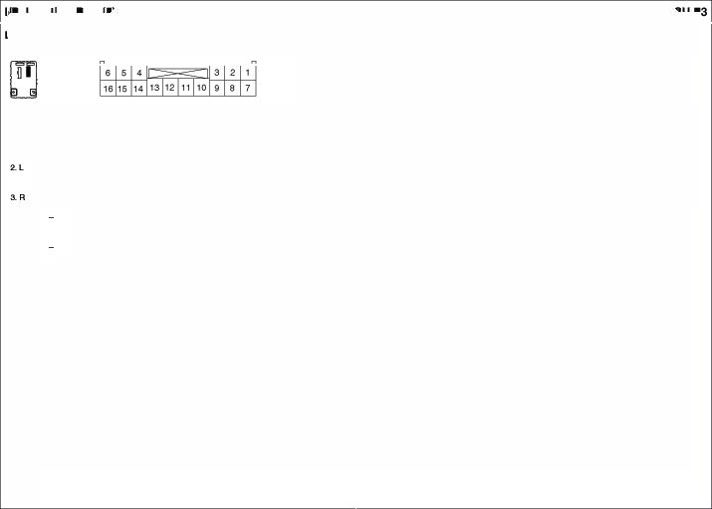RF Reol!i\'ef hYl.mel'llCl.dler
MIMJncion SMi::fl (Rl!9 W�, ICM Aday Box(Real' �Aday)
1&B Ground (GM01

EMS (Engine Management System) Box (1)
M x
•20 F-emaia/�le (AM _090111_20F_W) · 20Feme.1&IWhile (KET

I.y NCc.rn,.-. 11.- - 1.L ImmobilizerMo<l.11& 11.- -

3.2.81 PCM(AIC Re�y) 12.l llieclOf 11
2.Q9G
eart. CJoeeY#le
1112.
12. w OIeon.ol Vilv911/2

4.-
-�..
13. p
14. -

llieclOf13
CarnshEtftP06111on Sen6or
13.- -

5.W
6.-
lgnilioflCQI

15.IJO-
- ear;. PurgeC«*olSolenoid 14.G< EJR FU9E1 &RelayBox
llieclOff2 V"'9 E�Cofwot Relay

- 16.
9.GP lgniliof\CQI'' 1&0 �
- 3. G</8 Variable�Manlfotd VM (Clfan LORelay)

7.&
_c.o.. 17.- -
<.G
°'PC
15.WiOStlo,_s..- !IJI>

lgnilioflCQIf3 19.- - s.WKJStlEV
0
l.B 16.0

o._s..- !CoM>

10.- - 20.W PCM(Engine

°"'°" S...0.(0own)
  - PCM

Conuot Relay'CH 1.....0 ·· - (EngineConlt Relay 'QfInput)

7.- -
18. -

8. - 19.- -

•10••.l
....._...... 20 PCM(F�Amy
Pe (E CoolrdAel& Ccw1rd)

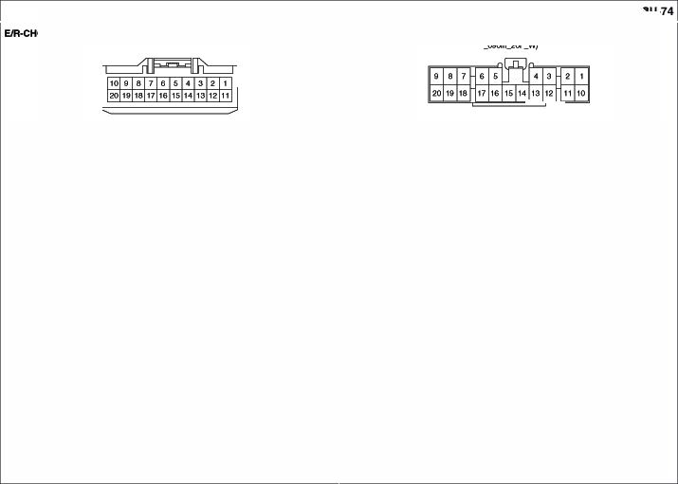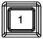
EIR�MS EM Bo
1
    - Female/NIA(CA01F070t

I. R '411ti FUM EMS.tOA

JcMnt COnn.ctor
•8 FEl'l'ltl/Black(KET_070_06F_B_JCKJ •20 F-emara/E!ladc (t(ET_090ll_20F_B_JCKJ
- C-CAN Commurbulon lkl •8-CA &C-CAN ComR'llrbtlon Une

1.0 C. (Low)·NCeo-i -.ie, 11.G C-CA (H91 •A/CCon1tol Moch.'9
1.0 | Lew•Dau.lS\kCcnnec:ti:s | 6.G High• DataUi*CoMedot
2.0 | Lew·PCM | 8.G High PCM
3.0 | Lew·M�Chec: | 1.G High•Wlip..-poseOledc
 | """"""" | ""'-""
4.- | - | 8.- -

�MO<Ue TI1e Pfe9e91.1r Monitoring Module

•4F�/wt'lile (KET_090IL04f_W)
TA Pre66ure
�o C. (Low)·4WOE<:M 1�0 C-CA (H91 4W ECM.
OitaUrt: ()Qlla lin Conn9cl0f
3.0 C. (Low)•k'IGti.wnen CllSEW 13.G C-CA (H91 • IRIMll'nElnlCb'tef EPS Coon1lol Mo<llle- EPSCon.-d MocUe
•. - - 14.- -
(1<9> •Sil
�o | C. | (Low)·SRS Control Module | 1S.G | C-CA
e.o | C. | (Low)·PCM |  | Mod'*>

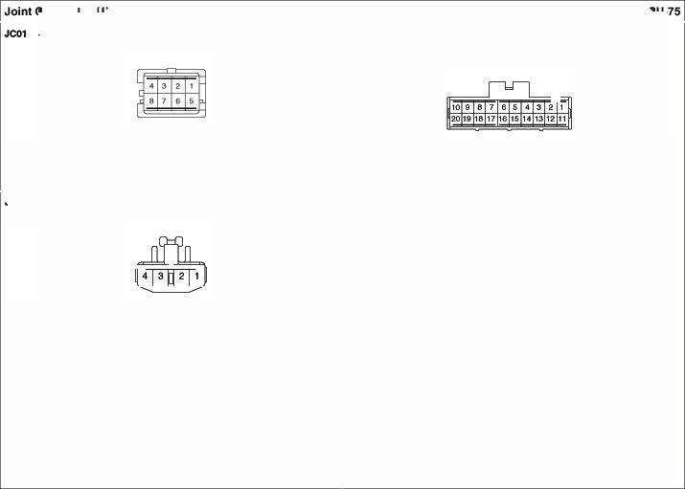
ESCMoch.'9 POOS 1e.G C-CA (1<9> • PCM
.. _Chocl<W-:.0. E SC,_,,..POOS.
1. - - M�Check ConnEICIOf
e. R 8-CA llO'fr) · lnstrumen �l9f 17.- -
9. 8-CA llO'fr) · PO SrnertKey 1 .l �(Hlgli) •klslti.wnen CllSef
�-- 19.l �(Hlgli) •POM SmartKey
10.A 8-CA llO'fr) · IPSControl Modol$ Con1tol Moch.'9
BCM 20.l �(Hlgli) •FS C«*olMO<Ue
  - 1cu RelayBoll. oec Aday a""' Smar1Key Cor'*olMlolt.lle 8CM
�G POM G ESC Mo<llel
<.G Slop Lalf{:> SM�

•20 N!Jmale/El:ldc (t(ET_09011_20F_B_JCKJ
    - � No. 1 -10: AheoeW (·) orGIOW'ld(GM
- �No 11 - 20 11PJunction8ox(IPS 3ConlJOI

- LIO ATMSIWl:Levef
Wi Aheoetat lJO IU. (-)
W/OFtleoetat
8 010!.Sld(GM
- LIO ln&W\llnEl"I(ClJe'tef Wi NYNawloallon
AN Navigation Heed Module W/ONY Nawloallon
Audi>
- f\.O �P�9ox(IPS3)
AIC C.O..ol Mo<kil&
- f\.O ATM Shlrtl.Ew9 Ill.,
Wlti ANNIMgillon
NVNl:wi!gaton Headlr.kxUe­ W/OANNIMgillon
-
- f\.O AUX&US8Jl:'d Glcw9 Box�
- f\.O OBC 9'Mctl ESCC* &.itch
l�f\.O 4WOLock

�uo
4.lJO
�uo
e.lJO
1.UO e.lJO
NCConltOI Moehle ESCOffSYMcti Hau1dStMctl
�­
---Conod) oecS"'1ch
4W Loe*Switch. SW. StopIMton 6-
- f\.O lns1nrnent Cl1.1ME1
- f\.O M!Ailuldon�(Remote Con1tcl Cigarette Uf1119J&Froni
-°"""
18.. f\.O Hamid S'Mdl Al'l9ol;.W
19. f\.I() Con&ote Switch
20..f\.O Frcnt�DeicerSIWlctl.

9. LIO Hont Wiper Oeloer &.itch

Flee•Deloogel" Switch

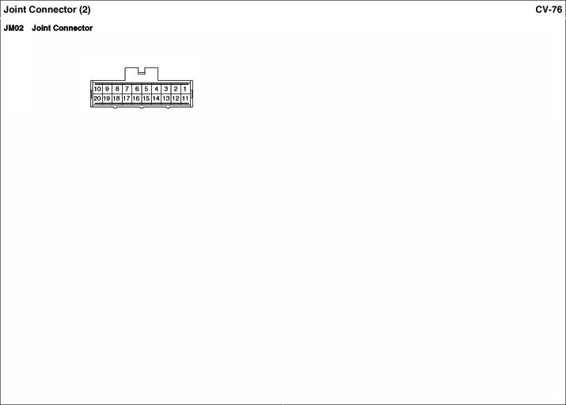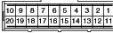
10.-
--�-

